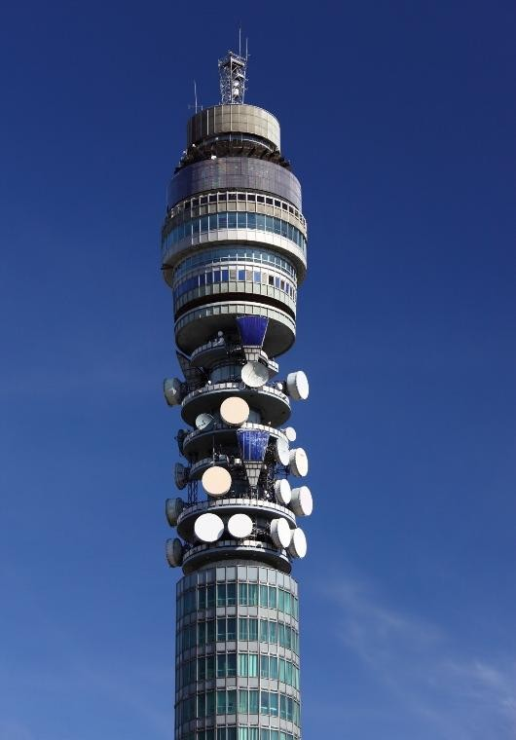
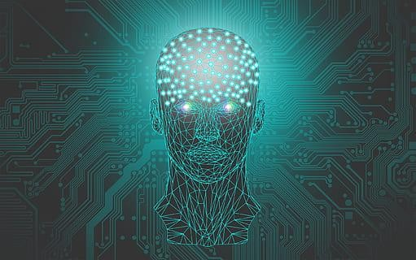
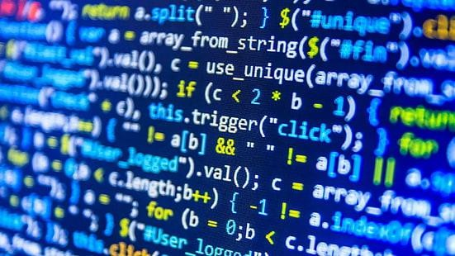


English for Informatics 2
9th Edition (Updated)
Compiled by
Atiqah Nurul Asri
JTI Polinema Internal Use ONLY 2026

Table of Contents
UNIT 1 1
Programming 1
- Stages in Programming 2
- Flowcharting 6
- Programming Languages 11
- Grammatical Functions: Reporting Screen Message 15
UNIT 2 17
Database 17
- Database Basics 18
- Grammatical Functions: If-Clause 25
- Data Processing 26
- Data Storage Device 27
UNIT 3 31
Computer Security 31
- Computer Threats and Safety 32
- Grammatical Functions: Simple Past Tense 36
UNIT 4 41
E-commerce 41
- Online Shopping and Transactions 42
- Online Shop Features 46
- Grammatical Functions: Nouns, Adverbs of Quantity, and Conjunctions (and, but, so, or) 47
- Online Transaction Security 54
UNIT 5 56
E-Publishing: Product Page 56
- Product Page 57
- Product Descriptions 60
- Grammatical Functions Used in Describing Products 65
UNIT 6 77
Recent Development in Information Technology 77
- Video Games 78
- Other Current Developments in IT 83
- Grammatical Functions: Simple Future Tense 86
- Writing a Summary of an IT Related Article 87

REFERENCES 91

UNIT 1

Programming


Learning Outcomes:
By the end of the lesson, the students are expected to be able to use appropriate English to:
- identify and explain steps in programming.
- identify symbols used in making a flowchart and their functions.
- interpret a flowchart.
- draw a flowchart and explain it.
- identify and explain kinds of programming languages.
- report screen messages using reported speech form.

Stages in Programming

Exercise 1: Have you ever seen any programming code? Here is an example of a C program. What does the program tell you? .
#include <stdio.h> main ()
{
Printf(“good
morning\n”);
}
Then, discuss with your partner what you think programming is and would you like to be good at programming.
Look at the section of code and the explanations and answer these questions.
  - Find an example of a constant in the code.
  - What do you think the value of x is, after the third instruction?

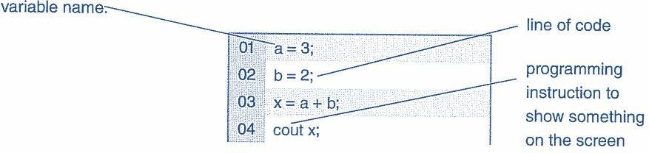
‘a’ is a variable. A variable is something that can change its value (which can be a number). The opposite is a constant: a constant cannot change its value. For example, here the number ‘3’ is a constant but ‘a’ is a variable: ‘3’ is always ‘3’ but ‘a’ can have any value an instruction gives it: it can be 1, 2, 3, or any other number. This instruction gives it the value ‘3’, which it keeps until another instruction changes it. Variables can have any name, and sometime variable names are quite long. For example, ‘g_Turn’ is a variable name.

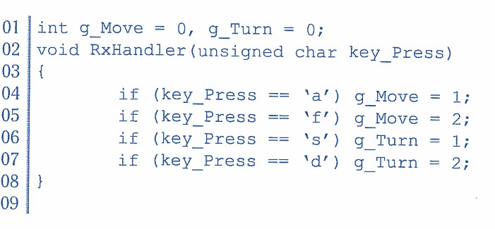
Exercise 2: Listen to the first part of a conversation between two programmers talking about this code, which controls a robot using a mobile phone. Number the variables in the order they are explained.

g_Turn key_Press g_Move

Complete the sentences. Then listen again and check your answers.
    - If g_Move has the value 0, the robot doesn’t move.
    - If g_Turn has the value 0, the robot doesn’t turn.
    - If you press ‘x’ on the phone, key_Press has the value x.

Exercise 3: Listen to the second part of the conversation between the two programmers. Label these illustrations with the keys that correspond to each direction.

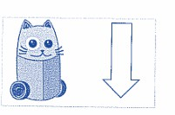


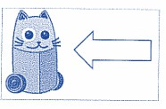

1. s 2. d 3. w 4. a

Exercise 4: Match the words 1-5 with the definition (A-E).

- flowchart
- source code
- compiler
- machine code
- debugging
- assembly
language
- high-level
language
- markup language
- program instructions written in a particular computer language
- language used to create and format documents for the Web
- the techniques of detecting and correcting errors which may occur in programs
- programming languages such as C, Java, or Visual Basic
- a diagram representing the successful logical steps of the program.
- Low-level language translated into machine code
- a special program which converts the source program into machine code-the only language understood by the processor.
- the basic instructions understood by computers, consisting of 1s and 0s (binary code).

Answer
1 – E
2 – A
3 – G
4 – H
5 – C
6 – F
7 – D
8 – B
Exercise 5: Listen to Andrea Finch, a software developer, talking to a group of students on a training course about how a program is written. You can also check the answer of Exercise 4 above.

Exercise 6: Listen again and put these steps into the correct order.
  - Write instructions in a programming language
  - Prepare documentation
  - Understand the problem and plan a solution
  - Take a flowchart of the program
  - Compile the program (to turn it into machine code)
  - Test and debug the program

Exercise 7: Fill the missing words to complete the text. Use the words in the box.
errors program compiled debugging flowchart documentation language
Steps in Programming
To write a (1)program software engineers usually follow these steps. First, they try to understand the problem and define the purpose of the program. Next, they design a step-by-step plan of instructions. This usually takes the form of a (2) flowchart, a diagram that uses standardized symbols showing the logical relationship between the various parts of the program. These logical steps are then translated into instructions written in a high-level computer (3) language(PASCAL, COBOL, C++, etc.). These computer instructions are called the ‘source code’. The program is then (4) compiled, a process that converts the source code into machine code (binary code), the language that computers understand.
Testing program are then run to detect (5) errors in the program. Errors are known as
‘bugs’, and the process of correcting these errors is called (6) debugging. Engineers must find the origin of each error, then write the correct instruction, compile the program again, and conduct another series of tests. Debugging continues until the program runs smoothly.
Finally, software developers write detailed (7) documentation for the users. Manuals tell us how to use programs like word processors, databases, or web browsers.
Taken from Infotech English for Computer Users Workbook, pp.50

Exercise 8: Discuss and explain each step in your own words.

Programming starts with understanding the problem and mapping out the logic using a flowchart, then writing the instructions as source code. This code is compiled into machine language so the computer can process it. Next, the program is tested to find bugs and debugged until it runs smoothly, and finally, documentation is created to guide the users.

Flowcharting

Exercise 9: Programmers sometimes use a flowchart when they are planning a program. The following symbols are used in making a flowchart. Identify each and its function.

No. | Symbols |  |  | Names | Functions
1. |  |  |  | (Terminal): | shows the start or the end of the flowchart
2. |  |  |  | Input/Output (Parallelogram) | shows data going into the program or results coming out of  it
3. |  |  |  | Process (Rectangle) | shows an action, a calculation, or an instruction in the program
4. |  |  |  | Decision (Diamond) | shows a question with a yes/no or true/false answer, and the flow can  go in different directions
5. |  |  |  | Flow line (Arrow) | shows the direction of the steps, connecting one symbol to the next
6. |  |  |  | Connector (Circle) | connects different parts of the flowchart on the same page
7. |  |  |  | Off-page Connector (Pentagon) | shows that the flowchart continues on another page

Exercise 10: Read this text carefully and then do the exercises.
So far, we have dealt mainly with computers, but now it is imperative that we find out how a program is written. In all activities involving computers, the programmer must be aware of what the machine is doing and what a program is supposed to do. As previously mentioned, flowcharting, one of the steps in programming, indicates the logical path the computer will follow in executing a program; it is a drawing very much like a road map. Flowcharting is not restricted to the preparation of programs in a particular language and should be done for each major problem before the writing of the program is attempted. If the finished program does not run as it should, the errors are more easily detected on the
flowchart than in the maze of words, characters, and numbers that make up the computer program. In order to develop a flowchart successfully, a programmer should be aware of the sequence of steps needed to obtain a correct solution to a problem.
There are two ways of making a flowchart; the freehand version and the neater, more readable version. In the former version, the graphic outlines are simply jotted down as the steps of the program are worked out. This is quite satisfactory if the flowchart is not intended to be kept as a permanent record. However, if a permanent, neater and more readable flowchart is needed, the latter method whereby a template, a sheet of plastic with all the flowcharting symbols cut into it, is used.
The following symbol should be used for the purpose of uniformity. The first and last
symbol is . This is the terminal symbol which indicates the beginning or the end of a program. The word 'START’ must be inserted inside the figure if it is the beginning of the program and 'STOP' if it is the end of the program.
The figure in the form of a parallelogram  is used as an input/output symbol. It indicates that something is either brought to or taken from the program. The rectangular

symbol stands for processing and indicates a place in the program where action is taken. In a program, to indicate that a decision has to be made, the diamond-shaped symbol

is used. The decision is usually in the form of a question that must be answered by

either 'yes’ or 'no'. Finally, the arrow is used to show the flow or direction in which the different actions in the program are performed.
It should be noted that a flowchart is not a program, but only a step in the preparation of a program, and is used in determining how to set up and write the program. However, if the problem is not understood, neither the flowchart nor the program can be done correctly. It is possible for two programmers, working separately; to write programs to solve the same problem and come up with flowcharts and programs that may be altogether different.
After a program has been worked out, it is usually written down and kept with a copy of the flowchart along with detailed instructions for the use and interpretation of the program. This procedure is part of what is referred to as program documentation. If documentation isn't available, it is always possible to work backwards and make a flowchart from an application program. It may be necessary to create a new flowchart when the original one is missing, in order to understand the program for which it was a preparatory step.
Flowcharting is one of the first things a student programmer is taught, because a flowchart shows how a person thinks about a problem. In other words, it is through this that a new programmer reveals his or her logical and analytical ability, which is a must in programming.
Taken from English for Computer Science, pp. 197.

Decide whether the following statements are true (T) or false (F). Then make the necessary changes so that false statements become true.

- A good flowchart takes into account the steps which are necessary to solve the problem.(T)
- It is not possible to draw a flowchart without using a template.(F)
- There is only one possible flowchart for every problem.(F)
- Every programmer must learn flowcharting and realize its importance.(T)
- The method of flowcharting depends on the programming language being used.(F)
- Flowcharts show the logic one has to follow to solve a problem.(T)
- Documenting a program is essential in explaining what the program is supposed to do.
(T)

- If the flowchart is correct, the program will work.(F)
- Each symbol in flowcharting has a specific meaning.(T)
- Flowcharts can show processes, but not decisions.(F)

Exercise 11: Flowchart David’s activities by completing the flowchart below.
David gets up in the morning, gets washed, and dressed. Before having breakfast, he checks to see if the newspaper has been delivered. If it has, he takes and puts it in the living room before sitting down to breakfast. After breakfast, he checks to make sure that he has completed all assigned homework. If there is still some to be done, he does it. Then he checks the clock, and if it is time to go, he leaves for the campus. If not, he reads the newspaper until it is time to go.

- Read newspaper.  - Take in and put newspaper in the living room.  - Get up, wash, and dress.  - Check time.  - Newspaper delivered?  - Go to the campus. | - Time to go?  - Any homework?  - Have breakfast.  - Complete homework.  - Start.  - Stop

Flowchart: David’s daily activities

Take in newspaper put in living room
Read Newspaper
Stop
Go to campus
Time to go
Check Time
Complete Homework
Any Homework?
Have Breakfast

Newspaper delivered?
Get up wash, and dress
start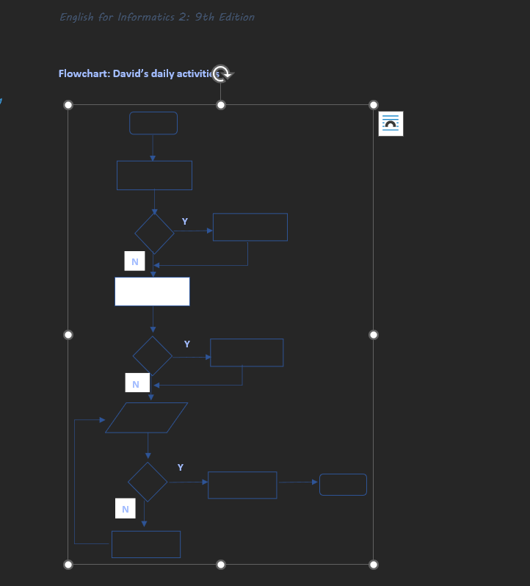
Y
N
Y
N
Y
N

Exercise 12: Draw a flowchart for one of these activities.
- Buying something from a vending machine
- Buying a new computer/smartphone.
- Preparing for an important exam.
- Withdrawing money from ATM.
- Re-registering a new semester.
- Booking a ticket online.
- Choosing a college or university.
- Planning a vacation.
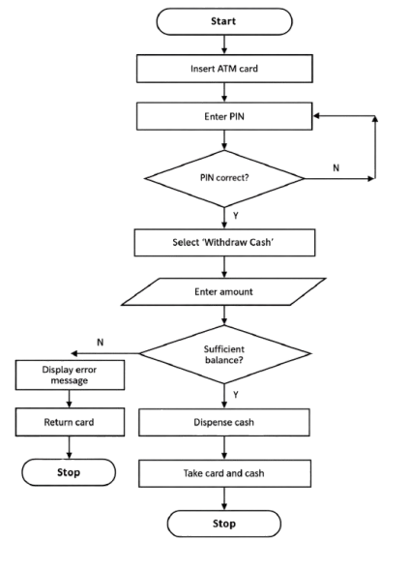

Exercise 13: Now, write the description of the flowchart you have made on Exercise 10 and present it in front of the class.
The flowchart illustrates the process of withdrawing cash from an ATM. The process starts when the user inserts their ATM card and enters their PIN. The system then checks whether the PIN is correct. If the PIN is incorrect, the user is asked to enter the PIN again. If the PIN is correct, the user selects the “Withdraw Cash” option and enters the desired withdrawal amount.
Next, the system checks whether the account has sufficient balance. If the balance is insufficient, an error message is displayed, the card is returned, and the process stops. If the balance is sufficient, the ATM dispenses the requested cash. Finally, the user takes the card and cash, and the transaction ends.

Programming Languages

Exercise 14: Find 10 words about Programming.
F | H | C | G | Y | B | U | G | S | F | R
L | S | O | I | R | A | H | M | E | A | E
O | R | M | G | R | S | M | C | Z | D | P
W | L | P | X | Y | I | O | M | O | C | A
C | P | I | G | R | C | M | C | F | A | S
H | R | L | S | S | A | O | M | E | L | C
A | C | E | G | P | A | M | B | L | Z | A
R | D | R | G | R | A | Q | M | O | R | L
T | C | O | I | E | A | M | C | U | L | G
O | R | T | D | E | B | U | G | G | E | R
P | R | O | G | R | A | M | M | E | R | O
1. FLOWCHART
2. COMPILER
3. BASIC
4. PASCAL
5. DEBUGGER
6. PROGRAM
7. BUG

Exercise 15: Read the text carefully and answer the following questions.

Computer Languages
Unfortunately for us, computers can’t understand spoken English or any other natural language. The only language they can understand directly is machine code, which consists of 1s and 0s (binary code).
Machine code is too difficult to write. For this reason, we use symbolic language to communicate instructions to the computer. For example, assembly languages use abbreviations such as ADD, SUB, and MPY to represent instructions. The program is then translated into machine code by a piece of software called an assembler. Machine code and assembly languages are called low-level languages because they are closer to the hardware. They are quite complex and restricted to particular machines. To make the programs easier to write and to overcome the problem of intercommunication between different types of computers, software developers designed high-level languages, which are closer to the English language. Here are some examples:
- FORTRAN was developed by IBM in 1954 and is still used for scientific and engineering applications.
- COBOL (Common Business Oriented Language) was developed in 1959 and is mainly used for business applications.
- BASIC was developed in the 1960s and was widely used in microcomputer programming because it was easy to learn. Visual BASIC is a modern version of the old BASIC language, used to build graphical elements such as buttons and windows in Windows programs.
- PASCAL was created in 1971. It is used in universities to teach the fundamentals of programming.
- C was developed in the 1980s at AT&T; it is used to write system software, graphics, and commercial applications. C++ is a version of C which incorporates object–oriented programming: the programmer concentrates on particular things (a piece of text, a graphic, or a table, etc.) and gives each object functions which can be altered without changing the entire program. For example, to add a new graphics format, the

programmer needs to rework just the graphics object. This makes programs easier to modify.
- Java was designed by Sun in 1995 to run on the Web. Java applets provide animation and interactive features on web pages.

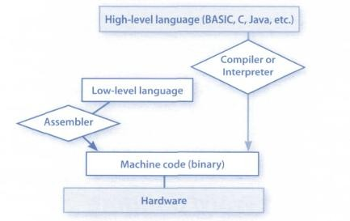
Programs written in high–level languages must be translated into machine code by a compiler or an interpreter. A compiler translates the source code into object code – that is, it converts the entire program into machine code in one go. On the other hand, an interpreter translates the source code line by line as the program is running.
It is important not to confuse programming languages with markup languages, used to create web documents. Markup languages use instructions, known as markup tags, to format and link text files. Some examples include:
- HTML which allows us to describe how information will be displayed on web pages.
- XML which stands for EXtensible Markup Language. While HTML uses pre-defined tags, XML enables us to define our own tags; it is not limited by a fixed set of tags.
- VoiceXML, which makes Web content accessible via voice and phone. VoiceXML is used to create voice applications that run on the phone, whereas HTML is used to create visual applications (for example, web pages).
<xml>
<name> Andrea Finch </name>
<homework> write a paragraph describing the C language </homework>
</xml>

In this XML example, we have created two new tags: <name> and <homework>.

Taken from Infotech English for Computer Users, pp.121

Answer the questions briefly.
- Do computers understand human languages? Why/Why not?
No. Computers cannot understand human languages directly because they only understand machine code (binary: 1s and 0s).
- What is the function of an assembler?
An assembler translates assembly language into machine code.
- How many high-level languages are mentioned? What are they?
There are six high-level languages mentioned in the text, namely FORTRAN, COBOL, BASIC, PASCAL, C/C++, and Java.
- Why did software developers design high-level languages?
Software developers designed high-level languages to make programs easier to write and to allow better communication between different types of computers.
- What is the difference between a compiler and an interpreter?
A compiler translates the entire program into machine/object code at once, while an interpreter translates and executes the program line by line.
- Why are HTML and VoiceXML called markup languages?
HTML and VoiceXML are called markup languages because they use markup tags to format, describe, and link information in documents or web content.

Exercise 16: Complete these sentences with a computer language from the text.
- Xml allows us to create our own tags to describe our data better. We aren’t constrained by a pre-defined set of tags the way we are with HTML.
- IBM developed FORTRAN in the 1950s. It was the first high-level language in data processing.
- Java applets are small programs that run automatically on web pages and let you watch animated characters, play games, etc.
- VoiceXml is the HTML of the voice web. Instead of using a web browser and a keyboard, you interact with a voice browser by listening to pre-recorded audio output and sending audio input through a telephone.
- This language is widely used in the business community. For example, the statement ADD VAT to NET-PRICE could be used in a Cobol program.

Grammatical Functions: Reporting Screen Message

A screen message is a notification or message displayed on a device's screen, often providing information or guidance related to the current task or application. It can be a system-level message, a notification from an app, or a customized message configured by the user.
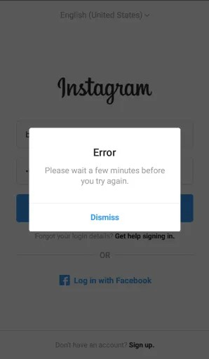
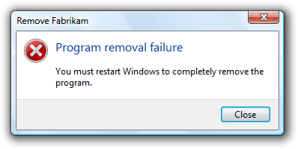
Look at the examples:

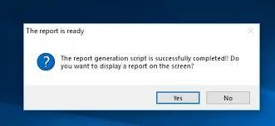
Sometimes, the message is not understood, and users may ask someone to explain its meaning. Here is how to report it. Pay attention to the italic words.

Please enter the number.  Type 999 to indicate end of data.  Do not attempt to log in. The printer is out of paper.  Do you want to exit? What is your password?  How many copies do you want to copy? | It requires you to enter a number.  It tells you to type 999 to indicate the end of the data.  It tells you not to attempt to log on.  It informs you that the printer is out of paper.  It asks you if/whether you want to exit. It asks you what your password is.  It asks you how many copies you want to copy.

Exercise 17: Report each of these screen messages.
  - Make sure the printer is switched on before continuing.
It tells you to make sure the printer is switched on before continuing.
  - Game mode is on.
It informs you that game mode is on.
  - Do you want to create a new document?
It asks you if/whether you want to create a new document.
  - What is the captcha code?
It asks you what the captcha code is.
  - Fill in your name in the box.
It tells you to fill in your name in the box.
  - Please type the next number.
It tells you to type the next number.
  - Enter your password.
It tells you to enter your password.
  - Please choose from menu below.
It tells you to choose from the menu below..
  - Can’t rename “Pictures” because a folder with that name already exists.
It informs you that you can't rename 'Pictures' because a folder with that name already exists.
  - Exit?
It asks you if/whether you want to exit
  - Are you sure you want to copy the selected files?
It asks you if/whether you are sure you want to copy the selected files
  - Do you want to defrag the drive?
It asks you if/whether you want to defrag the drive.
  - Mute story and posts?
It asks you if/whether you want to mute story and posts.
  - If you unfollow this account, you’ll have to request to follow again.
It informs you that if you unfollow this account, you'll have to request to follow again
  - Click the subscribe button to follow us.
It tells you to click the subscribe button to follow us.

UNIT 2

Database


Learning outcomes:
By the end of the lesson, the students are expected to be able to use appropriate English to:
- identify and explain field and record of a database.
- identify and explain part of database.
- identify and explain types of data in database.
- identify, explain, and make the selection rules to search data in a database.
- identify and explain wildcard characters to search data.
- use appropriate if sentences.
- identify and explain about data processing.
- identify and explain about data storage devices.

- Database Basics

Exercise 1: Study this example of a record from a database of company employees. Which fields do you think it contains? What other fields might be useful?
Aulia Akbar | Marketing | Sales Person | 30/5/1990 | Rp. 7.000.000,-

Exercise 2: Study this simple database of volcanoes and answer the questions.
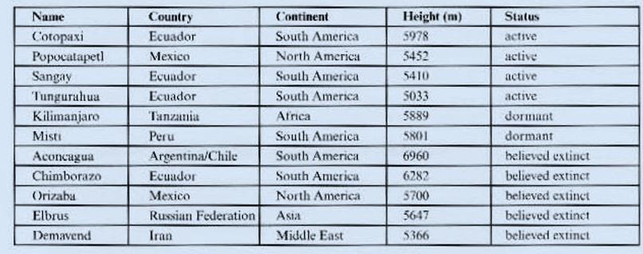

- How many fields are there?
- How many records are there?
- List the volcanoes in North America.
- List the volcanoes over 6,000 meters
- List the volcanoes that are believed extinct and whose heights are less than 6,000 meters.

Exercise 3: Look at the picture and read the text about Search Facility. Then answer the questions.
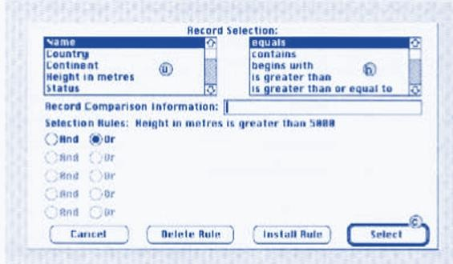  The ’search’ facility allows you to look through the database for information. To do this, you must enter the field or fields that you want to search and the details that you want to find. This is called to search on the field using whatever conditions you | require. To give an example, you might be looking for items on your database with ’height in meters greater than  5,000’. Here, the field that you would be  searching is ’height in metres’, and the  condition that you want is ’greater than 5,000.’ The figure shows how a simple search on one field can be carried out.
Taken from: Oxford Basic English for Computing, pp.70

- What does box a contain?
- What does box b contain?
- Which selection rule is entered?
- What is the function of button c?
- How many records will this search find?
- What are the selection rules to find:
  - all active volcanoes
  - all volcanoes in South America
  - all active volcanoes in Ecuador
  - all active volcanoes in South America higher than 5,500 meters

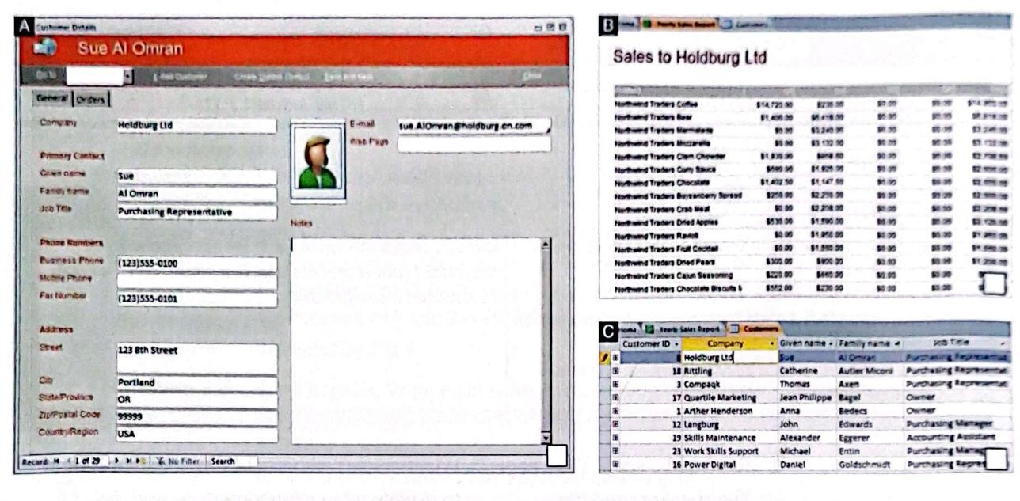
Exercise 4: Listen to a database administrator describing the structure of a company database to a trainee. Match these words to screenshots A-C.

    - report
    - table
    - form

Listen again. Which option best describes what the database keeps track of?
- clients and orders
- stock and orders
- orders and full accounts

Read the text about Part of Database below and do the exercises.

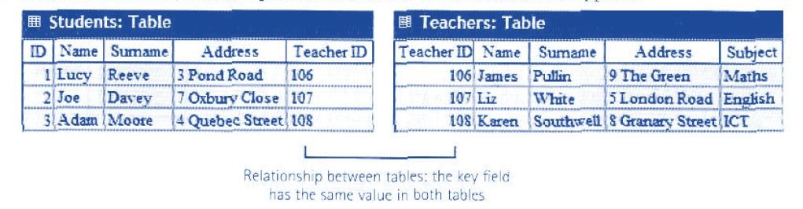
Database Basics
Database is essentially a computerized record-keeping system. Each unit of information you create is called a record, and each record is made up of a collection of fields. Typically, a single record consists of a set of field names like: Title, First Name, Surname, Job Title, TelNo, and ID. You fill in a form with relevant information for each field to add a new record to the database. There are different data types.
  - Text – holds letters and numbers not used in calculations
  - Number – can only hold numbers used in calculations and reports
Work in pairs. What fields would you include in a database for the following cases? Design
theirdatabase forms.
a. A national police computer’s database of criminal cases.
b. A dentist’s database of patients.
c. A travel agents’ database of airline tickets.
d. A public library’s of members.
e. A language school’s database of students.
  - Memo – can store long texts
  - Date/Time – a date or time or combination of both
  - Auto number – assigns a number to each record
  - OLE Object – (object linking and embedding) holds sounds and pictures
  - Yes/No – for alternative values like true/false, yes/no, on/off, etc.
  - Hyperlink – adds a link to a website

Once you have added data to a set of records, indexes must be created to help the database find specific records and sort (classify) records faster. An index performs the same function as in the back of a book or a library. For example, if you regularly search your database by surname, the index should be defined on this field.

Relational Database
Two database files can be related or joined as long as they hold a piece of data in common. A file of employee names, for example, could include a field called ‘DEPARTMENT NUMBER’, and another file, containing details of the department itself, could include the same field. This common field can be used to link the two files together.
Extracting information from a database is known as performing a query. For example, if you want to know all customers that spend more than $9,000 per month, the program will search the name field and the money field simultaneously.

Taken from Professional English in Use ICT, pp.36-37

Fill in the blank using words in the text to complete this passage.

A (1) program allows the user to store, change, and retrieve information. A database file is a collection of records. Each (2) contains a set of fields. Each (3) holds a separate piece of information; for example, a student file contains a list of records, each of which consists of several fields that give their name, address, birthday, etc.
In a (4) database, information is stored in tables that have a connection or link with one another.
A database lets you create an (5), a list of records ordered according to the content of certain fields; this helps you search and (6) records into numerical or alphabetical order very fast. It also has a (7) function which allows you to extract information that meets certain criteria.
Taken from Professional English in Use ICT, pp. 37

Exercise 5: Look at this form. Decide which data type each of these numbers.

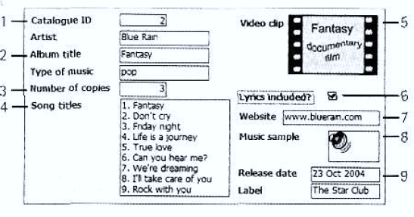
1.
2.
3.
4.
5.
6.
7.
8.
9.

Exercise 6: Read the text about wildcard characters carefully, then do the exercise that follows.
In most databases, you can use wildcard characters when you do not know exactly what you are searching for. Study these examples.
? any single character in this position
* any number of characters in this position
# a single number in this position
[] find these characters
[!] don’t find these characters

Using these characters in a search. We can be certain what we will find and what we will not find.
Example: If you search for Sm?th, you will find Smith and Smyth, but you won’t find Smit.

(Taken from Basic English for Computing, pp.72)

Write similar sentences to the above example for these searches:
- ?ry - cry, dry, try, pray
- b*d - bed, bread, bead, breed, breath
- #th - 7th, 55th, path
- Fred[ao] - Fredi, Freda, Fredo
- Mart[!o] - Marta, Marti, Marto

Exercise 7: Find at least 3 other wildcard characters, explain them, and give examples.

Exercise 8: Some databases use symbols rather than words for selection rules. Here are some of the symbols and their meanings:
= | equals, equal to | <> | not equal to
=> | equals or greater than | .AND. | And
> | greater than | .OR. | or
=< | equals or less than | .NOT. | Not
< | less than

Study this extract from the database of members of a sports club, and the results of five searches. Write selection rules to obtain these results. Use the symbols above. (Note: to make sure that you have written the right selection rules, you can prove it using any database application).
Example:
Search result: Helen Trim
Selection rule: Occupation = technician.AND.sex=F

First Name | Surname | Sex | Age | Occupation | Residence
Lilias | Brown | F | 21 | student | Los Angeles
Lucy | Cruden | F | 28 | actrees | New York
Alan | Brew | M | 24 | student | Chicago
Helen | Trim | F | 23 | technician | Boston
John | Walls | M | 26 | student | New York
John | Pond | M | 31 | computing officer | San Fransisco
Arnold | Bright | M | 31 | technician | Los Angeles

No. | Search Results | Selection Rules
1.  2.  3.  4. | Lilias Brown, Alan Brew, John Walls John Pond, John Walls  Lucy Cruden, Helen Trim Lilias Brown, Arnold Bright

Grammatical Functions: If-Clause

Exercise 9: Read the explanation of the if sentence, then do the exercise that follows.
The sentence begins with an if clause (the underlined clause of the example above); thus, it is named if sentence. After the if clause, the other part of the sentence is named an independent clause, where there is a subject, you, and a modal, will.
We use will when we are certain one action will follow another. For example:
If you switch on Caps Lock, you will get all capital letters.
However, when we are less certain that one action will follow another, we can use these expressions:
- will probably/possibly
- probably/possibly won’t
- may (not), might (not)
Complete if sentences below using an appropriate expression of certainty Example: If there is a power failure, you may lose all your data.
  - If there is a power failure, you lose all your data.
  - If you have a virus, it corrupt your files.
  - If you don’t back up your files regularly, you lose some of them.
  - If you can choose a simple password, someone access your files.
  - If you don’t give your files meaningful names, you forget what they contain.
  - If you copy pirated software, your PC have a problem with computer viruses.
  - If you never read computer magazines, you miss important new products.
  - If I know more programming languages, I get a better job.

Data Processing

Exercise 10: Match the headings in the box to the data processing steps A-F.
data coding data collection
data entry
data sorting
data tabulation data validation

- gather the raw data that you want to process.
- arrange and systemise the data.
- clean the data and double-check for faults and inconsistencies.
- enter the data into a system.
- arrange the data into table format so that it can be analysed.
- create categories to organize the data into relevant groups.

Exercise 11: Put the data processing steps from Exercise 10 into the correct order.
Exercise 12: Listen to an IT expert describing the data processing steps to a colleague. Check your answers to Exercise 10 and 11 above.



Data Storage Device

Exercise 13: Look at the pictures and descriptions about Types of Magnetic Storage below and identify the following:
  - The name of the hard drive on a PC platform
  - The type of hard drive that plugs into a socket at the back of a computer
  - The system that works in a sequential format
  - The size and storage capacity of a floppy disk

A 3.5” floppy drive and diskette
A floppy disk drive uses
3.5” disks, which can store
1.44 MB of data; it is usually assigned to the A: drive. Floppy drives are becoming increasingly rare.
The inside of a hard drive Most PCs have one internal hard drive, usually called C: drive. It is used to store the

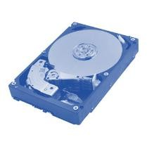
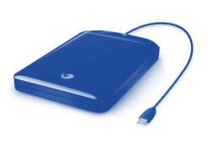
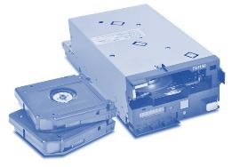
operating system, the programs, and the user’s files conveniently. A hard drive can hold hundreds of gigabytes of data.

A portable external hard drive
External hard drives are connected to the USB or
Fire Wire port of the computer. They can be as small as a wallet but can have as much capacity as internal drives; they are typically used for backup or as secondary storage.

Magnetic tapes and drives
A tape drive reads and writes data on tapes. It
is sequential-access- i.e., to get to a particular point on the tape, it must go through all the preceding points. Tapes can hold hundreds of gigabytes of data and are used for data collection, backup, and archiving.

Exercise 14: Complete the following sentences using the words in the box.
capacity storage archiving hold secondary

- There are basically three types of magnetic devices available to computer users: hard drives, diskettes, and tapes.
- The of a 3.5” floppy disk is only 1.44 MB.
- Hard drives can hundreds of times more data than floppy disks.
- A portable hard drive is a good choice for storage.
- Magnetic tapes are used for information that you no longer need to use regularly.

Exercise 15: Sue wants to buy a new drive. Listen to her conversation with the sales assistant. Does she buy anything? How do you know?

Exercise 16: Listen to the conversation and answer these questions.
- What is the storage capacity of the Iomega eGo portable hard drive?
- How much information can be stored on the Edge DiskGo model?
- Which hard drive is good for mobile professionals?
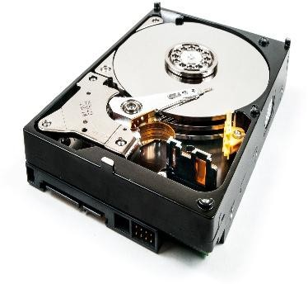
- How much does the Iomega eGo drive cost?
- How much does the Edge DiskGo cost?

Exercise 17: Read the text about Optical Storage and answer the following questions.

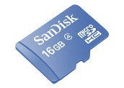
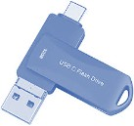
Optical drives use a laser to read and write data, so they are not affected by magnetic fields; but they are slower than hard drives. Modern DVD recorders accept all CD and DVD formats.

CDs (Compact Disks) can store up to 650-700 MB of data.  - CD-ROMs (Read Only Memory) are ‘read-  only’ units, so you cannot change data stored on them (e.g. a dictionary or a game).  - CD-R (recordable) discs are write-once devices which let you duplicate CDs.  - CD-RW (rewritable) discs enable you to write onto them in multiple sessions, like a hard disk. | DVDs (Digital Versatile Discs) are similar in size to CDs (both are 1.2 mm thick), but they differ in structure and capacity. DVDs have more tracks and more pits (tiny holes) per track, and can store from 4.7 GB to 17 GB of data, movies, high-definition sound, etc., so they will probably replace CDs. DVD formats include:  - DVD-ROM (Read-Only Memory)  - DVD-R or DVD+R (Recordable Only Once)  - DVD-RW or DVD+RW (rewritable, so it can be erased and used many times).
Portable DVD players let you watch movies or TV, play games, and listen to music, wherever you are. They usually run on batteries, have a widescreen (rectangular 16:9 format) LCD and support multi-format playback, allowing you to play many file formats, including DVD video, JPEG pictures, MP3 music, etc. They have two built-in stereo speakers, or headphones if you do not want to disturb other people.
Removable flash memory

Flash memory is solid-state, rewritable memory; it is non-volatile, so it retains data when the power is turned off. This explains its popularity in small devices.
  - Flash memory cards such as CompactFlash or Secure Digital are found in cameras, PDAs and music players.
  - Flash drives, also known as thumb or pen drives, are connected to a USB port of the computer. They let you save and transfer data easily.

Find the terms in the text to match the following descriptions.
- the CD and DVD formats that can be written many times
- the CD and DVD formats that can be written to by the user only once
- the CD and DVD formats that can be read by a computer but not written to
- the type of cards used in digital cameras
- a type of drive that plugs into a USB port and lets you share photos and music with friends
- the memory without moving parts; it is erasable, non-volatile, and used in small devices
- the expression that means to ‘initialize and prepare it to receive data’

Exercise 18: Discuss this with your partner. What device or format would be most suitable for storing these items?
- the operating system and the programs on the home computer
- an electronic encyclopedia for children
- a movie in digital format
- the music tracks by your favorite artist
- all the files generated by a company in one day
- the phone taken with a digital camera

UNIT 3

Computer Security



Learning Outcomes:
By the end of the lesson, the students are expected to be able to use appropriate English to:
  - identify and explain about computer threats and their prevention and solutions.
  - identify and explain kinds of computer crimes.
  - analyze a computer crime and present it to the class.
  - understand the use of the past simple.
  - create an infographic about computer security.

Computer Threats and Safety

Exercise 1: Work in pairs. Discuss what kinds of computer threats you know and how to prevent and solve them.

Exercise 2: Read the descriptions 1-8. Match the words in the box to the descriptions.

adware | hacker | browser hijacker | malware attack
spyware | Trojan | virus | worm

  - Malicious software that can copy itself and infect the system.
  - A program that is usually free but contains malicious files.
  - A program that automatically plays commercials on a computer.
  - Affects privacy. It does not take control of a computer system, but sends information about the use of a computer system.
  - An effort to gain unauthorized access to a computer.
  - Spreads without the user taking action and usually acts in operation system.
  - A person, who on purpose attempts to break into a computer system and use it without the knowledge of the owner.
  - Software that replaces the user’s search engine with its own.

Exercise 3: Match the security solution 1-5 to its purpose A-E.

- a firewall.
- antivirus software.
- authentication.
- username, password, and biometric scanning.
- encryption.
- prevents damage that viruses might cause.
- make sure only authorized people access the network.
- checks the user is allowed to use system.
- blocks unauthorized access codes.

- protects the system from public places.

Exercise 4: Listen to this dialogue and answer the questions. Ludek has asked his IT expert friend, Ales, for help.
- Why does Ludek want Ales to check his laptop?
- Why is Ludek worried that he may lose his project?
- What does Ales think has happened to Ludek’s laptop?
- Why does he recommend that Ludek install anti-spyware software?
- Why is it important to have a network access password?
- What will Ales do for Ludek?

Exercise 5: Read the following texts about Internet Security, Malware: Viruses, Worms, Trojans, and Spyware and Preventative Tips.

Internet Crime

The internet provides a wide variety of opportunities for communication and development, but unfortunately, it also has its dark side.
Crackers, or black-hat hackers, are computer criminals who use technology to perform a variety of crimes: virus propagation, fraud, intellectual property theft, etc.
Internet-based crimes include scams, email fraud to obtain money or valuables, and phishing, bank fraud, to get banking information such as passwords of Internet bank accounts or credit card details. Both crimes use emails and websites that look like those of real organizations.
Due to its anonymity, the Internet also provides the right environment for cyberstalking, for online harassment or abuse, mainly in chat rooms or newsgroups.
Piracy, the illegal copying and distribution of copyrighted software, information, music, and video files, is widespread. But by far the most common type of crime involves malware.

Malware: viruses, worms, Trojans, and spyware
Malware (malicious software) is software created to damage or alter computer data or its operations. These are the main types.
- Viruses are programs that spread by attaching themselves to executable files or documents. When the infected program is run, the virus propagates to other files or programs on the computer. Some viruses are designed to work at a particular time or on a specific date, e.g., on Friday the 13th. An email virus spreads by sending a copy of itself to everyone in an email address book.
- Worms are self-copying programs that can move from one computer to another without human help, by exploiting security flaws in computer networks. Worms are self-contained and don’t need to be attached to a document or program the way viruses do.
- Trojan horses are malicious programs disguised as innocent-looking files or embedded within legitimate software. Once they are activated, they may affect the computer in a variety of ways: some are just annoying, others are more ominous, creating a backdoor to the computer which can be used to collect stored data. They do not copy themselves or reproduce by infecting other files.
- Spyware, software designed to collect information from computers for commercial or criminal purposes, is another example of malicious software. It usually comes hidden in fake freeware or shareware applications downloadable from the internet.
Page | 33

Preventative Tips:
- Do not open attachments from unknown people; always take note of the file extension.
- Run and update antivirus programs, e.g., virus scanners
- Install a firewall, a program designed to prevent spyware from gaining access to the internal network.
- Make backup copies of your files regularly.
- Do not accept files from high-risk sources.
- Use a digital certificate, an electronic way of proving your identity, when you are doing business on the internet. Avoid giving credit card numbers.
- Do not believe everything on the net. Have a suspicious attitude toward its contents.
Taken from Professional English in Use ICT pp.62

Identify the internet crimes sentences 1-6 refer to. Then match them with the advice (A-F).

  - Crackers try to find a way to copy the latest game or computer program.
  - A study has revealed that half a million people will automatically open an email they believe to be from their bank and happily send off all their security details.
  - This software’s danger is hidden behind an attractive appearance. That’s why it is often
wrapped in attractive packages promising photos of celebrities like Anna Kournikova or Jennifer Lopez.
  - There is a particular danger in internet commerce and emails. Many people believe they have been offered a special gift, only to find out later they have been deceived.
  - ’Nimda’ spreads by sending infected emails and is also able to infect websites, so when a user visits a compromised website, the browser can infect the computer.
  - Every day, milions of children spend time in internet chat rooms talking to strangers. But what many of them do not realize is that some of the surfers chatting with them may be sexual predators.
- People should not buy cracked software and download music illegally from the internet.
- Be suspicious of wonderful offers. Don’t buy if you aren’t sure.
- It’s dangerous to give personal information to people you contact in chat rooms.
- Don’t open attachments from people you don’t know, even if the subject looks attractive.
- Scan your email and be careful about the websites you visit.
- Check with your bank before sending information.

Exercise 6: Fill in the gaps in these security tips with words from the box.
digital certificate malware virus scanner spyware firewall anti-virus
  - Malicious software can be avoided by following some basic rules.
  - Internet users who like cybershopping should get a , an electronic identity card.
  - To prevent crackers from breaking into your internal network and obtaining your data, install a . It will protect you from .
  - If you have been hit by a , don’t panic! Download a clean-up utility and always remember to use an program, for example, a virus .

Exercise 7: In pairs, please discuss the following questions.

- What do you do to prevent computer infections?
- Do you keep your virus protection updated? The internet has lots of websites where you can get free advice and software. What should you do to improve your computer security?

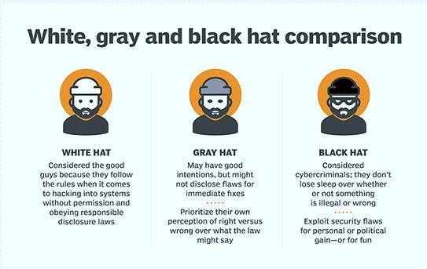
Exercise 8: Study the following comparison of types of hackers. Discuss them with your partner.

Grammatical Functions: Simple Past Tense

Exercise 9: Read Part 1 of the History of Hacking below and answer the questions.
  - Which hacking case inspired the film War Games?
  - When did Captain Zap hack into the Pentagon?
  - Why was Nicholas Whitely arrested in 1988?
  - How old was the hacker who broke into the US defence computer in 1989?

 | The History of Hacking – Part 1
1971 | John Draper discovered that a whistle offered in boxes of Cap’n Crunch breakfast cereal perfectly generated the 2,600Hz signal used by the T&T phone company. He started to make  free calls. He was arrested in 1972 but wasn’t sent to prison.
1974 | Kevin Mitnik, a legend among hackers, began hacking into banking networks and altering the credit reports of his enemies. He didn’t expect that his most famous exploit – hacking into the North American Defense Command in Colorado Springs – would inspire the film War  Games in 1983.
1981 | Ian Murphy, a 23-year-old known as Captain Zap on the networks, hacked into the White  House and the Pentagon.
1987 | The IBM international network was paralysed by a hacker’s Christmas message.
1988 | The Union Bank of Switzerland almost lost £32 million to hackers. Nicholas Whitely was  arrested in connection with the virus spreading.
1989 | A 15-year-old hacker cracked the US defence computer.
1991 | Kevin Poulsen, known as Dark Dante on the networks, was accused of stealing military files.  Taken from Infotect English for Computer Users, pp.96

Past Simple

- We use the past simple to talk about a complete action or event which happened at a specific time in the past.  past now  He began hacking in 1974.  - We form the past simple of regular verbs (V2) by adding (-ed) to the basic form of the verb (V1). | - We form questions and negatives using did/didn’t.  When did captain Zap hack into the Pentagon?  He didn’t expect that his most famous hacking would inspire a producer to make a movie.  - We form the past passive with the past simple of be + the past participle (V3).

John Draper discovered that a whistle in boxes of Cap’n Crunch breakfast cereal perfectly generated the 2,600Hz signal used by the T&T phone company.  - Some verbs are irregular in the past simple.  Kevin Mitnik began hacking into banking networks and altering the credit reports of his enemies.  begin – began | He was arrested in 1972 but wasn’t sent to prison.  The IBM international network was paralysed by a hacker’s Christmas message.

Exercise 10: Read Part 2 of the History of Hacking below and fill in the table using the correct simple past forms of the verbs in the box.
show spread steal launch attempt overwrite be infect affect

In 1992, David L Smith was (1) prosecuted for writing the Melissa virus, which was passed in Word files sent via email. In 1997 the German Chaos Computer Club (2) on TV how to obtain money from bank accounts. In 2000, a Russian hacker (3) to extort $100,000 from online music retailer CD Universe. A Canadian hacker (4) a massive denial service attack againts websites like Yahoo! And Amazon. IloveYou virus, cleverly disguised as a love letter, (5) so quickly that email had to be shut down in many companies. The worm (6) image and sound files with a copy of itself. In 2001, the Code Red Worm (7) tens of thousands of machines. In 2006, hackers (8) the credit cards details for almost 20,000 AT&T online customers, However, subscribers to its service (not)
* (9).

*passive form

Exercise 11: In small groups, look at the list of cybercrimes below and discuss the following questions. Write a summary of your discussion in PowerPoint and present it to the rest of the class.

- Which crime is the most dangerous?
- Is it fair or unfair to pay for the songs, videos, or articles that you download? Should copyright violations be allowed online?
- What laws can be taken by the government to stop cybercrimes?
- Do you think governments have the right to censor material on the internet?
- Personal information such as our address, salary, and civil and criminal records is held in databases by marketing companies. Is our privacy in danger?
Cybercrimes
- Piracy – the illegal copy and distribution of copyrighted software, games, or music files.
- Plagiarism and theft of intellectual property – pretending that someone else’s work is your own.
- Spreading of malicious software.
- Phishing (Password Harvesting Fishing) getting passwords for online bank accounts or credit card numbers by using emails that look like they are from real organizations, but they are in fact fake; people believe the message is from their bank and security details.
- IP Spoofing – making one computer look like another to gain unauthorized access.
- Cyberstalking – online harassment or abuse, mainly in chat rooms or newsgroups.
- Distribution of indecent or offensive material.

Taken from Infotech English for Computer Users, pp.98

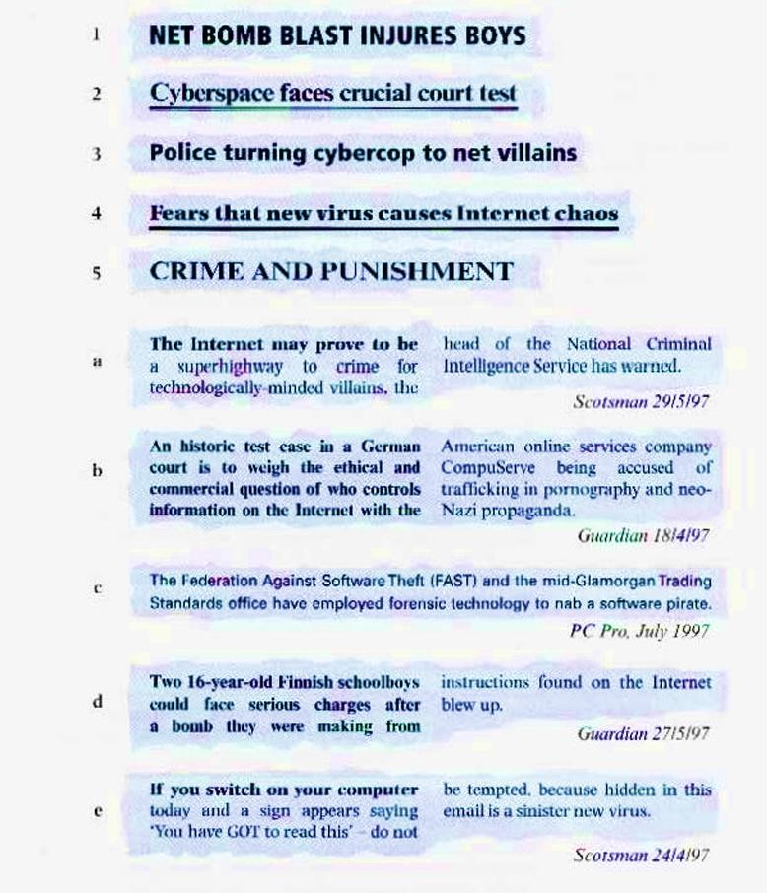
Exercise 12: These headlines cover some of the ethical issues involved in computing. Work in pairs. Try to match the headlines to the first sentence of each story.

Exercise 13: Work in pairs. Find an article from a newspaper about a computer crime in Indonesia and match it with the Information and Electronic Transactions (UU ITE No. 19 Tahun 2016). Answer and discuss the following questions.
- From the news, identify:
  - The doers/criminals
  - The crime committed
  - The punishment
- Do you think the punishment fits the crime? Why? Why not?
- What should people do to prevent themselves from being the victims of such crimes?
- In what articles and laws did the suspect violate the crime?

Exercise 14: Work with the same partner. Create an infographic dealing with computer security, especially on the following topics:
- How to prevent a malware attack
- Crackers vs Hackers
- Spyware vs Malware
- How to protect the computer from spyware
- How to solve Phishing
- How to solve an attack from a Trojan virus

Here are examples of infographics.
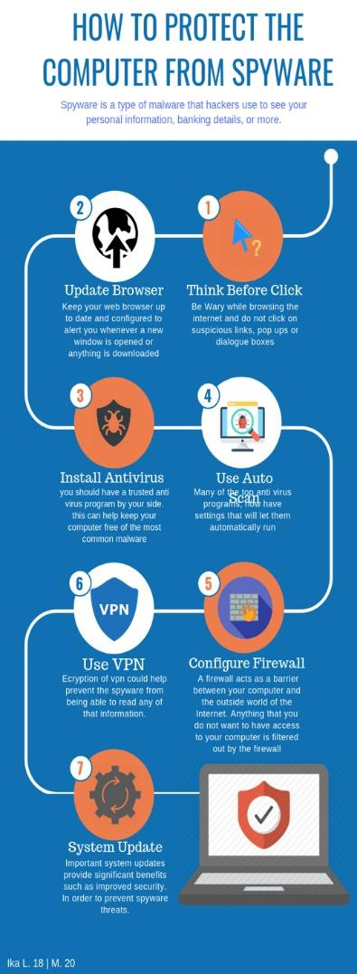
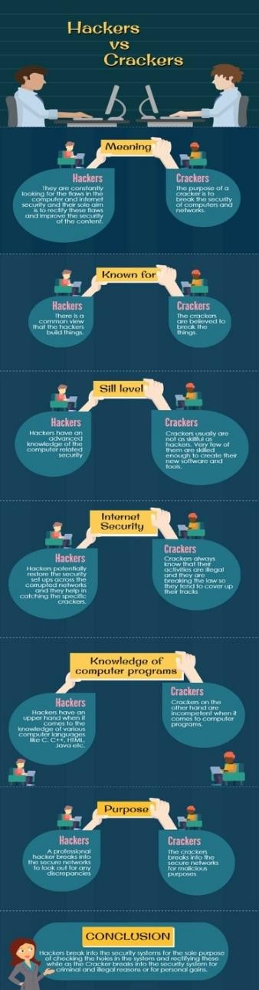
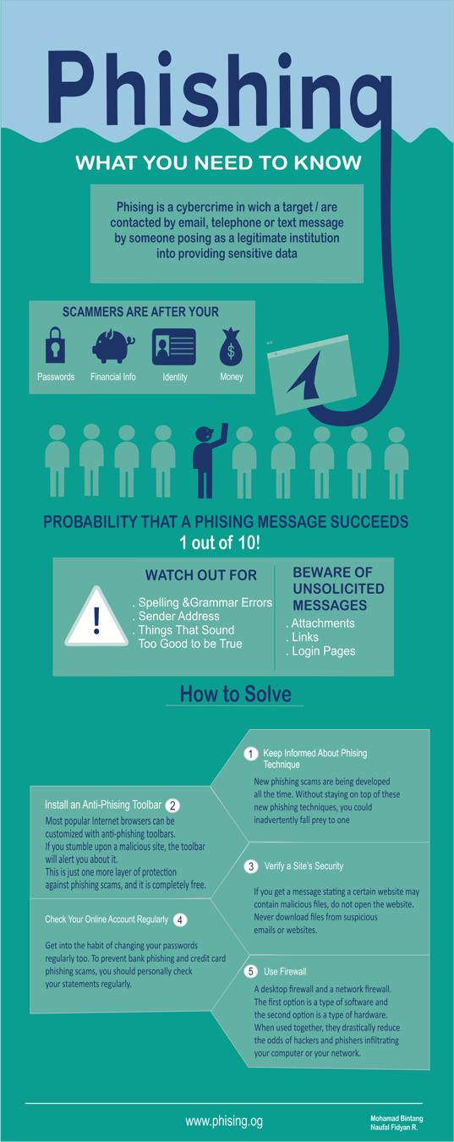

UNIT 4

E-commerce


Learning Outcomes:
By the end of the lesson, the students are expected to be able to use appropriate English to:
- explain the definition of E-commerce.
- tell their experiences related to online shopping.
- explain types of online shopping.
- explain about online transactions.
- identify adverbs of quantity and differentiate their uses.
- understand and make sentences using adverbs of quantity.
- understand and make sentences using the connectors and, but, or, and so.
- read and understand the email about security issues.
- identify and explain safety issues in online transactions.

Online Shopping and Transactions

Exercise 1: Work in pairs. Explain the definition of e-commerce. Is it the same as online shopping? Share it with the class.

Exercise 2: Share your experience while doing online shopping. What products or services do you usually buy online? What product do you not buy online? What are the considerations you have before deciding to buy an item through online shopping? Do you have any bad experiences in buying an item online? What happened?



Exercise 3: You are going to listen to an interview with David Aston. He works for a company that sells home cleaning products. Mark the statement True (T) or False (F).

  - David’s company sells mainly online. T / F
  - 70% of their business is online. T / F

  - People buy their cleaning products when they buy their food.
T / F

  - People buy their cleaning products in supermarkets. T / F
  - Online sales are growing. T / F

Exercise 4: Read the following text about How to buy on the Internet and do the exercise.

How to Buy on the Internet
The first thing to do is to look for the product in a search engine, or even better, in a comparison engine or bargain finder, to find the lowest price.
Most online shop websites are designed so that customers follow these steps to do their virtual shopping:
    - You start by adding the items you want to buy to the shopping basket, or virtual shopping trolley.
    - When you have selected the items that you want to buy, you proceed to the payment section by clicking on the checkout button.
    - You may have to log in, provide your username and password, or sign up, by providing your personal data, billing and shipping address, etc., if this is the first time you have accessed the site.
    - You will be given an account, so you are recognized as a customer. You will be asked to enter payment details, e.g., credit card numbers, etc. Before the transaction is completed, you will be asked to confirm the order and check all the information is correct.
    - Finally, you log out and leave the website.
There are different types of electronic payment: credit cards and debit cards. A digital wallet, the electronic equivalent of a wallet for online shopping, holds credit card data and passwords for logging into websites. PayPal, Microsoft’s Passport, and Yahoo! Wallet are examples of digital wallets.

Taken from English Professional in Use ICT, pp. 64.

What are the steps in buying products online? Number these sentences in the correct order.
- The customer opens an account.
- The customer goes to the checkout.
- The customer puts the item(s) in a shopping cart.
- The customer pays for the product (s) with a credit or debit card.
- The customer goes to the website.
- The customer searches and/or browses the website.
- The customer chooses the item(s) to buy.
- The customer checks the order.

Exercise 5: Read about the information about types of e-commerce and do the exercise.
Types of E-commerce
Companies whose activity is centered on the internet are called dotcoms, after their web addresses. However, most e-commerce businesses are bricks and clicks, as they have both physical and online presence.
Although there are some examples of B2B commerce, business-to-business, e-commerce is mainly used for B2C, business-to-customer, or even for C2C, consumer-to-consumer. Internet auction websites like eBay, where people offer products and sell them to the highest bidder, are an example of C2C e-commerce.
Taken from English Professional in Use ICT, pp. 64.

Match the type of business in the box to the correct column 1-4. Add another example of each type.
B2C Business-to-Costumer
C2C Costumer-to-Customer
B2B Business-to-Business
M-commerce

Types of Business | 1. ......... | 2. .......... | 3. .......... | 4. ..........
Explanation | Companies exchange information and make wholesale  transactions. | Companies sell products or services to customers over the  Internet. | People sell or exchange second-hand, used items or collectibles. | Customers purchase products and services via mobile  devices.
Examples | Coffee supplier to  Nestlé | Amazon | eBay | News, sports results

Exercise 6: You are going to listen to a conversation. Shayan is telling Monika how customers will pay for something online on a new website. Complete this dialogue with the words in the box.

account | bank | completes | confirmation | customer
first | gateway | payment | rejection | web

Monika : Shayan, can you explain how a customer (1) an online transaction? Shayan : OK, it’s very easy. (2) the customer will place an order. The seller’s (3)
server will confirm availability of the product and send a response. After that, the customer checks out and completes the (4) instructions. Then the server will send a payment request to a payment (5) . The payment gateway will check the buyer’s ability to pay with the (6) . OK?
Monika : Fine. Go on.
Shayan : The bank will respond and send payment acceptance or (7) to the
seller’s web server through the payment gateway. Finally, the customer will receive the server response with the order (8) or rejection.
Monika : Will the (9) have to register?
Shayan : Yes, all buyers must have their (10) before they complete the transaction.
Monika : Thank you. Now I understand.

Online Shop Features

Exercise 8: Work with your group. Examine the picture. Identify features of the website (http://www.zalora.co.id). Do you think it is a good e-commerce website? Why? Give your reasons.
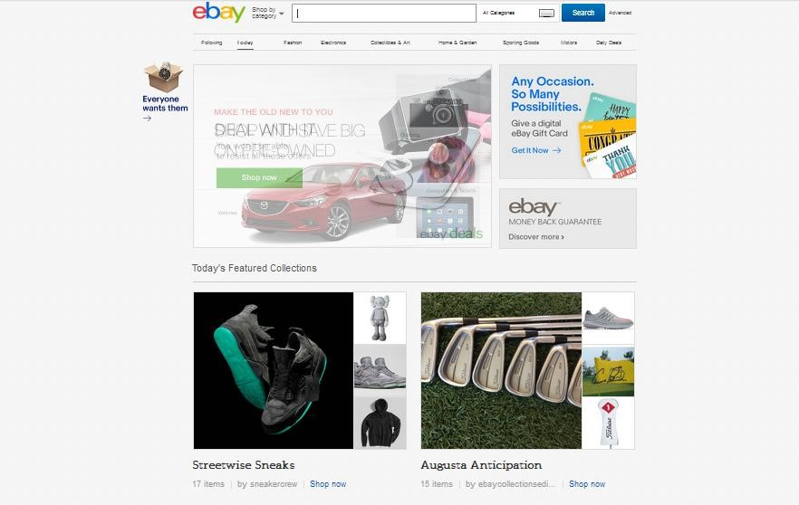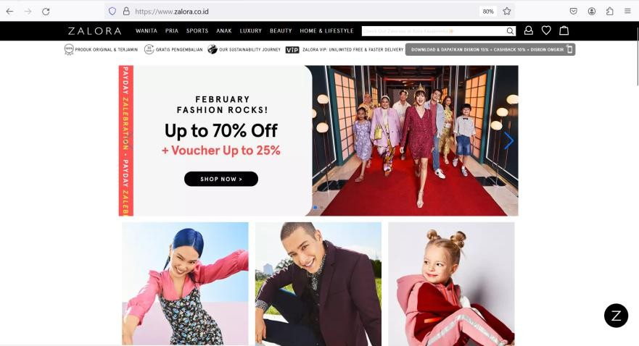

Exercise 9: Still work with the same group. Discuss an e-commerce website you know and like. Give reasons why you like it (its design, features, safety, etc).
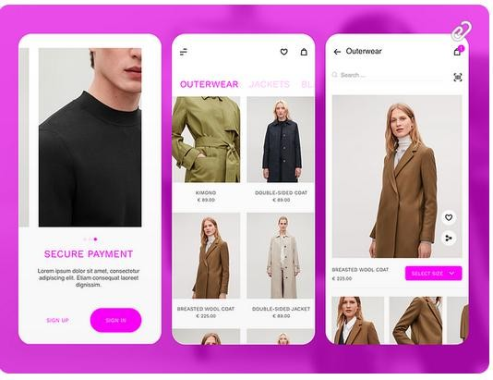

- Grammatical Functions: Nouns, Adverbs of Quantity, and Conjunctions (and, but, so, or)

When discussing a product or a service and data in E-commerce, you often use Nouns and Adverbs of Quantity. Nouns can be categorized as countable and uncountable.

Countable Nouns
Countable nouns are things you can count individually. They have both singular and plural forms.
- Singular: one product, one order
- Plural: two products, five orders
Countable nouns are common in E-commerce when talking about items, units, and measurable services.

Examples:

Singular | Plural | In a Sentence
product | products | "We offer over 500 products on our website."
item | items | "You can add up to 10 items to your cart."
order | orders | "He placed three separate orders last week."
customer | customers | "We value our loyal customers."
review | reviews | "This phone has over 1,000 reviews."
package | packages | "Your packages will arrive in 3–5 days."

Uncountable Nouns
Uncountable nouns are things you cannot count individually. They are often abstract concepts, materials, or mass nouns. These nouns do not have a plural form. Uncountable nouns in E-commerce are used for general categories, abstract ideas, or substances.

Examples:

Uncountable Noun | In a Sentence
information | "Customers need accurate product information."
data | "We analyze customer data to improve service."
money | "You must transfer the money before shipment."
feedback | "Your feedback helps us improve."
inventory | "We update our inventory daily."
shipping | "Shipping is free on all orders."
advertising | "Online advertising can increase sales."

Summary:

Concept | Countable Noun | Uncountable Noun
A physical thing | product, item | packaging, equipment
A person/group | customer, vendor | staff (often uncountable)
An abstract idea | complaint, message | feedback, information
Business material | document, file | content, advertising
Number reference | "two orders" | "some data"

Moreover, in describing a noun, you also need Adverbs of Quantity. Look at the table.

Adverb | Meaning | Example Sentence
a lot / a lot of | a large amount or degree | "She shops online a lot."
much | a large amount (usually in negative  or questions) | "There isn’t much time left."
many | a large number (used with  countable nouns) | "How many products do you sell?"
a little | a small amount (uncountable  nouns) | "We have a little information  about the product."
a few | a small number (countable nouns) | "There are a few items in your  cart."
some | an unspecified amount or number | "He added some products to his  Wishlist."
too much / too many | more than necessary | "You spend too much money on  apps."
enough | sufficient amount or number | "We don’t have enough stock."
plenty | more than enough | "There’s plenty of time to deliver."
no | none / zero amount | "We received no feedback from  that campaign."
little / few | not much / not many (negative  meaning) | "There is little interest in the  outdated model."

Exercise 10: Complete these sentences using appropriate Adverbs of Frequency.
- shops have online presence. They offer products online.
- companies offer customer services an advice on their E-commerce websites.
- I don’t have knowledge of computers, but I can still shop online.
- Companies spend money on E-commerce security.
- Even when companies only have money online marketing, they should spend it.
- The company gathered data on customer behavior.
- We have customers visiting our website daily.
- They received feedback after launching the product.
- Only orders were delayed due to shipping issues.
- There isn't information about the new product yet.

Exercise 11: Work in pairs. Use the words on the box (Exercise 13) to talk about your own online shopping habits.
For example:
I buy a lot of clothes online rather than go to the local mall.

Conjunctions

Conjunctions are words that connect words, phrases, or sentences. They help you build smoother, more complex sentences and express relationships between ideas.
The four common conjunctions (coordinating conjunctions) are: and, but, or, so.

and – addition
To add one idea to another or show that two things are true or happening together.

Examples:
- We sell clothes and accessories.
- She added the item to her cart and completed the checkout.

You can use and to connect:
- Words: T-shirt and jeans
- Phrases: buying shoes and returning items
- Full sentences: "He paid online and received a confirmation email.

but – contrast
To show opposite ideas or a surprising result. It also shows a contrast between what you expect and what happens.

Examples:
- I like the design, but it’s too expensive.
- She wanted the red dress, but it was out of stock.

so – result/effect
To show a result or consequence of an action or situation.

Examples:
- He forgot to apply the discount code, so he paid full price.
- The website was slow, so I left without ordering.

or – choice/alternative
To show a choice between two or more options. Use "or" to offer alternatives or ask yes/no questions.

Examples:
- Would you like to pay with PayPal or a credit card?
- You can contact us by phone or by email.

Summary:

Conjunction | Function | Example Sentence
and | addition | She bought a phone and a case.
but | contrast | He added the item to his cart, but didn’t buy it.
so | result/cause | The app crashed, so I restarted it.
or | choice | Do you want a receipt or not?

Exercise 12: Complete this text with the words in the box.

and but or so
Companies want to reach more customers, (1) they go online. It is easy to set up an online business (2) it is difficult to design and develop a website that attracts a lot of customers. Hardware (3) software provides basic infrastructure for E-commerce.
Networking, customer interface, and payment solutions are very important parts of a company’s E-commerce solution. Customers expect a fast and reliable service
(4) they will go somewhere else to buy things.
Taken from English for Information Technology 1, pp.39

Exercise 13: Match the first half of the sentences (1-6) to the second half (A-F)

  - Effective product information and
  - Customers can use their credit cards, PayPal, or
  - We used a lot of promotions, so
  - I don’t know how to buy online but,
  - They want to buy a Cat 5e cable, so
  - In e-commerce you can look at a picture of a product, but
- I’ll check online tutorials
- electronic cheques to pay for transactions
- you can’t touch it.
- our sales improved a lot.
- they search the internet.
- promotions attract customers

Online Transaction Security

Exercise 14: Read this email, then answer the following questions.

To: All employees
From: IT Director
Subject: Online transactions security

We are developing new website security features. We will have a virtual private network with a firewall which will help stop cyber-attacks on the network perimeter. The web application protection firewall (WAF) will protect our website from hacker attacks on customer contacts and login boxes. Secure Socket Layer (SSL) will create a secure connection for the users. We will have two-factor authentication (2FA). Website administrators will go through two layers of security before they access the hosting environment. This will prevent password leaks. All data will have encrypted backup to protect sensitive information.
I am sure the company will benefit from the new security measures. Thanks,
Hamda Banna
Taken from English for Information Technology 1, pp.40
  - What is the email about?
  - Who is Mr. Banna?
  - How many security features will the company have?
  - Which security feature will stop attacks on the company network?
  - What solution will protect customer contacts and login boxes?
  - What will protect private user information sent over the network?
  - What will the factor authentication protect?
  - What will protect information?

Exercise 15: Read the text about Online Security and do the exercises.
Online Security
Most online banks have introduced the concept of two-factor authentication, the simultaneous use of at least two different devices or layers of security to prevent fraud.
When you open an Internet account, you are given a confidential PIN, Personal Identification Number, and a password and username.
For some transactions, customers are required to use a TAN, Transaction Authorization Number, from a list provided by the bank. It can only be used once, and it acts as a second password.
Security tokens are microchip-based devices that generate a number that has to be typed by the user or read like a credit card. They are becoming a common form of two-factor authentication.
One of the best methods of identifying a user's bank account is biometric authentication, the use of physical traits, such as a fingerprint, to allow a person to log in. Some laptops have built in fingerprint readers, which makes online banking easier and more secure.
Taken from English Professional in Use ICT, pp. 64.

Complete this text with words from the text above.
Most financial institutions offering Internet-based products should use (1) authentication to reduce the risks of account fraud and identity theft.
At present, most authentication methodologies involve three basic factors:
- Something the user knows, for example a (2), the confidential number given by the institution.
- Something the user has, for example a (3), the keyring-like identification number generator.
- Something that shows who the user is, that is (4), for example a fingerprint. Authentication methods that depend on more than one factor are more reliable; for example, the use of a (5), a TAN (something the user knows) to log in, and then a token (something that user has) to transfer funds.
Adapted from Federal Institutions Examination Council.

UNIT 5

E-Publishing: Product Page


Learning Outcomes:
By the end of the lesson, the students are expected to be able to use appropriate English to:
- share their experiences related to online shopping.
- identify and explain criteria of an effective product page.
- create a product page.
- identify a product based on its descriptions.
- identify and explain grammatical functions used in describing a product.
- write a product description using the grammatical functions (Simple Present, Adjectives, Comparatives and Superlatives, Present Continues, Infinitives, and Gerunds).

Product Page

Exercise 1: Previously, we discussed a good e-commerce website. Related to the topic, think about the last item you bought online. What did you buy? Why did you buy it? What made you decide to buy the item at the store? Why were you so sure that your transaction is secure? When finally the item that you bought arrived, were you satisfied with it? Was it like what you once imagined? What are the criteria of a good product page? Share your thoughts with the class.
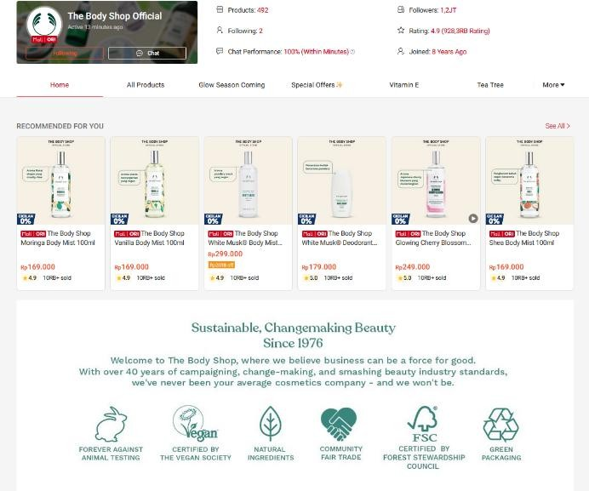
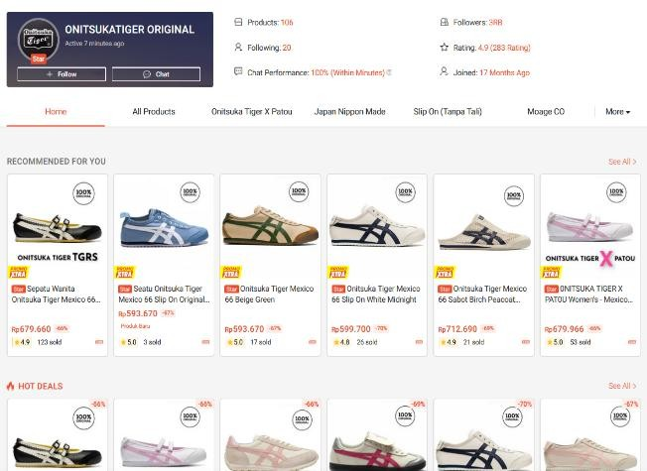

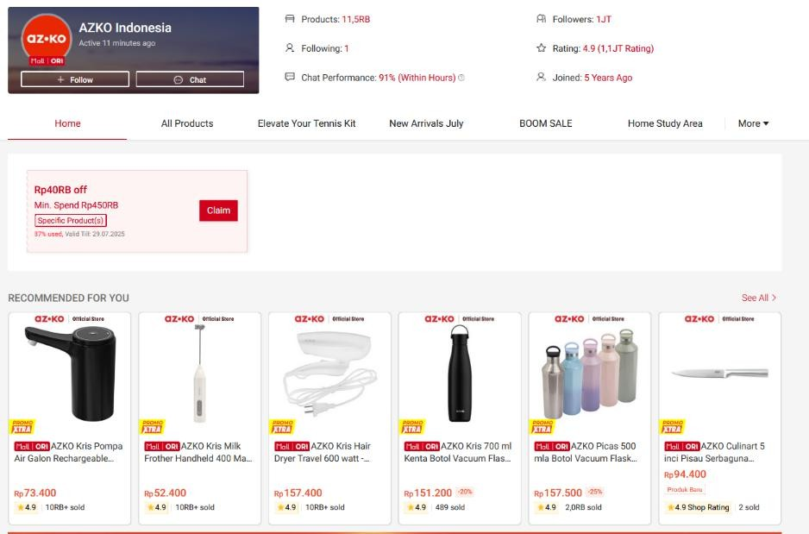

Exercise 2: Read the text and answer the questions.

Creating an Effective Product Page

Creating a successful product page requires understanding what attracts customers and keeps them interested. To design a page that sells, it's important to focus on several key elements.
One of the most important things is writing a clear and engaging product description. Avoiding confusion is essential to helping customers make informed decisions. Try using simple language and highlighting the main benefits of the product. Customers appreciate being able to understand what they are buying.
Another crucial step is adding high-quality images. These images help shoppers visualize the product and often lead to them choosing to buy it. Don’t forget to include multiple views of the item and to show the product in use when possible.
It’s also helpful to include reviews from other customers. People tend to trust the opinions of others before making a purchase. Encouraging satisfied buyers to leave positive reviews can significantly improve sales.
Remember, offering clear pricing and mentioning shipping details are essential to building trust. Customers want to know exactly what they are paying and how long they will wait.
Finally, make sure your call to action is strong. Phrases like “Buy Now” or “Add to Cart” motivate visitors to take the next step. The goal is to guide the customer toward purchasing without hesitation.
In summary, writing great product descriptions means combining useful information, emotional language, and a clear structure. By learning to combine strong visuals, useful information, and persuasive language, businesses can create a product page that leads to more conversions and happier customers.

Choose the best answer:
- What is the purpose of writing a clear product description?
  - to confuse the customer
  - to attract search engines
  - to help customers make informed decisions
  - to increase shipping time
- What do high-quality images help customers do?
  - understand return policies
  - visualize the product
  - avoid buying
  - ask questions

- What does the text suggest avoiding in descriptions?
  - confusion
  - keywords
  - pricing
  - shipping
- What do reviews encourage potential buyers to do?
  - trust the product
  - contact support
  - leave the site
  - cancel the order
- What helps build trust according to the text?
  - fancy fonts
  - long paragraphs
  - clear pricing and shipping details
  - including pop-ups
- What is the function of a call to action?
  - to guide customers to make a purchase
  - to collect emails
  - to explain the refund policy
  - to change the website layout
- Why should a product be shown in use?
  - to demonstrate real-life benefits
  - to show the store
  - to hide the flaws
  - to change colors
- What do satisfied buyers need to be encouraged to do?
  - buy more products
  - leave reviews
  - visit the warehouse
  - change their rating
- What is the main purpose of a product page?

  - to entertain
  - to convert visitors into buyers
  - to show off web design
  - to explain policies
- What does “offering clear pricing” help with?
  - slowing down the customer
  - building trust
  - increasing ad space
  - hiding fees

Exercise 3: After reading the text above, conclude what makes a product page effective. You may also add more reliable references about the criteria of an effective product page. Then, in pairs, find any e-commerce website available dan analyze whether it fulfills the criteria or not. And if you have to re-develop the website, what features will you add? Share with the class.

Product Descriptions

Exercise 4: Read the text and answer the questions.
Writing Effective Product Descriptions
Writing effective product descriptions is essential for selling products online. A good description helps customers understand what they are buying and encourages them to complete a purchase. One of the keys to success is knowing your target audience. Before writing anything, it's important to think about who will read the description. Are you trying to reach busy parents, tech lovers, or fashion enthusiasts?
Understanding your audience makes it easier to choose the right words and tone.
Using clear and simple language is another important step. Avoid using too many technical terms unless your audience expects them. Try to focus on the benefits of the product instead of just describing its features. For example, instead of saying "This phone has a 4000mAh battery," say "Enjoy using your phone all day without needing to recharge."
Adding emotion can also improve your product descriptions. People like feeling excited or inspired when they read about a product. Try to create a picture in their mind by describing how the product fits into their life.
Don’t forget to include keywords to help your page appear in search results. However, avoid stuffing your text with too many keywords, as this can make the description hard to read.
Finally, check your grammar and spelling. Taking time to review your text helps create a professional image. Customers are more likely to trust brands that pay attention to detail.
In summary, writing great product descriptions means combining useful information, emotional language, and a clear structure. By learning to write with purpose, you can boost sales and build customer trust.

Choose the best answer.
  - What is the main goal of a product description?
    - to help customers make a purchase
    - to compare prices
    - to show off writing skills
    - to test grammar knowledge
  - Why is it important to know your audience?
    - to choose the right words and tone
    - to guess what they want
    - to make the product cheaper
    - to impress other writers
  - What does the writer suggest using instead of only listing features?
    - long paragraphs
    - product benefits
    - technical details
    - brand history
  - Why should you add emotion to your descriptions?
    - to make the reader feel connected
    - to sound dramatic
    - to confuse the buyer
    - to hide product flaws
  - What does “Enjoy using your phone all day” focus on?
    - the brand name
    - a product feature
    - the benefit for the customer
    - the battery percentage
  - What can happen if you use too many keywords?
    - It will improve grammar.
    - It makes the text hard to read.
    - It helps the page load faster.
    - It lowers the product price.

  - What shows professionalism in product descriptions?
    - humor
    - correct grammar and spelling
    - fancy fonts
    - writing in all capital letters
  - What does the phrase "to write with purpose" mean?
    - to write with a clear goal
    - to write as fast as possible
    - to copy other descriptions
    - to add long words
  - What is recommended before writing a product description?
    - thinking about your audience
    - checking reviews
    - using slang
    - lowering the price
  - What does the text say about technical terms?
    - use them only if your audience expects them
    - always avoid them
    - use them in every sentence
    - translate them into emojis

Exercise 5: Match the pictures with their names.


- travel backpack A.


- electric toothbrush B.

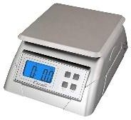
- desk lamp with USB port C.

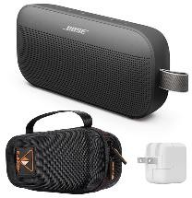
- noise-cancelling earbuds D.

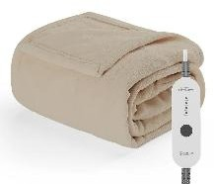
- reusable water bottle E.

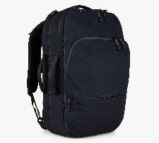
- laptop cooling pad F.

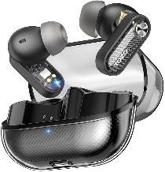
- digital kitchen scale G.

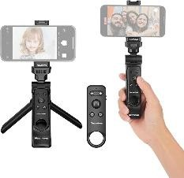
- bluetooth portable speaker H.


- heated blanket I.


- phone tripod with remote J.

Exercise 6: Match each product with its descriptions.

- travel backpack A. It keeps you warm during cold nights. It has different
heat settings, which you can change easily with a remote control. If you forget to turn it off, it will shut off automatically after a few hours.
- electric toothbrush B. It is used to measure ingredients accurately. It shows
the weight in grams or ounces, which is helpful for cooking and baking. With a clear screen and simple buttons, it is easy for anyone to use.
- desk lamp with USB port C. These are made for comfort, and they help block outside
noise. The sound is clear and powerful, and the case charges them automatically. If you use them for phone calls, your voice sounds natural and loud.
- noise-cancelling earbuds D. This has two built-in fans, keeps your laptop cool and
quiet. You only need to plug it into a USB port. It is light and easy to carry, perfect for working in different places.
- reusable water bottle E. This is small but powerful. You can connect it to your
phone using Bluetooth, and it plays music for up to 12 hours. If you take it outside, its water-resistant design keeps it safe from rain or splashes.

- laptop cooling pad F. It is made of stainless steel, safe for hot and cold drinks.
It keeps your drink cold for 24 hours or hot for 12 hours. To save plastic, use this bottle every day.
- digital kitchen scale G. This is light and strong, perfect for traveling or going to
school. It has many pockets, including one for your laptop, which helps you stay organized. With padded straps, you can carry it comfortably all day.
- Bluetooth portable speaker H. Take photos and videos more easily with this. It can hold
your phone in different angles and includes a small remote, which lets you take pictures from far away. It is light and easy to fold, so you can take it anywhere.
- heated blanket I. This is modern and flexible, ideal for a study desk. You
can adjust the arm to change the light angle. It also includes a USB port, which lets you charge your phone while working.
- phone tripod with remote J. It is designed to clean your teeth better than a regular
one. It comes with a timer to help you brush for the right amount of time. The brush, which charges quickly, can be used for up to 10 days on one charge.

- Grammatical Functions Used in Describing Products

Re-read Exercise 6 above. In describing a product, some grammatical functions are used. Here is the list:
Function | Explanation | Example
Present Simple | Describe facts and regular use | "The camera takes high-resolution  photos."
Adjectives | Describe appearance, quality, or  features | "A durable, lightweight suitcase."
Comparatives | Compare other products | "It is lighter than most backpacks."
Superlatives | Highlight best qualities | "Our most popular and affordable  model."
Passive voice | Emphasize the product, not the  doer | "It is made from eco-friendly  materials."
Present  Continuous | Describe ongoing trends or current  uses | "Customers are choosing this model  for its design."
Gerunds | Explain purpose or use | "Perfect for traveling and  photographing."
Infinitives | Show purpose or function | "Designed to last a lifetime."

In the previous Module for English 1 Course (Mata Kuliah Bahasa Inggris 1), you have learned about Simple Present Tense or Present Simple, Adjectives, Comparative and Superlative, and Passive Sentence. Now let’s review them. Do the Exercises below.

Exercise 7: Read the product description on Exercise 6 and identify which sentences are included in Simple Present Tense or Present Simple, Adjectives, Comparatives and Superlatives, and Passive Sentences. Complete the table.

Simple Present Tense | Adjectives | Comparatives and  Superlatives | Passive Sentences

Exercise 8: Choose the correct answer.
- The vacuum cleaner all types of floor surfaces.
  - clean
  - cleans
  - cleaning
  - cleaned
- This app users to track their fitness goals.
  - help
  - helping
  - helps

  - is help
- The device a notification when fully charged.
  - send
  - sends
  - is sent
  - sending
- Our service team customers 24/7.
  - support
  - supports
  - is supported
  - supported
- The software regularly for updates.
  - checks
  - is check
  - Check
  - checking
- The smartwatch your heart rate every minute.
  - monitor
  - monitored
  - monitors
  - is monitoring
- This model in three different colors.
  - come
  - comes
  - coming
  - is come
- Each printer with a free ink cartridge.
  - arrive
  - arrives
  - is arriving
  - arriving
- The design of the phone is sleek and .
  - modern
  - modernly
  - moderned
  - moderns
- The backpack is made of material.
  - durability
  - durable
  - durably

  - durableness
- The product is compact and very .
  - usefully
  - usage
  - useful
  - use
- The keyboard has a layout.
  - convenience
  - conveniently
  - convenient
  - convene
- This camera takes photos in low light.
  - clearly
  - clear
  - clarity
  - clearing
- The new model is more than the last one.
  - reliability
  - reliable
  - relied
  - relying
- The interface is simple and to navigate.
  - ease
  - easy
  - easing
  - easier
- This laptop is than the previous version.
  - light
  - lighter
  - more light
  - lightest
- This is the smartphone in our store.
  - faster
  - fast
  - fastest
  - more fast
- The speaker is than the older model.
  - more loud
  - louder
  - loudest

  - loud
- Our latest phone is the we've ever built.
  - most advanced
  - more advanced
  - advancedest
  - very advanced
- This model is than most others on the market.
  - affordable
  - more affordable
  - affordabler
  - most affordable
- That is the battery life of all our devices.
  - good
  - better
  - best
  - most better
- The screen is than the previous version.
  - brighter
  - more bright
  - most bright
  - brighting
- The products carefully before shipment.
  - checks
  - are checked
  - is checked
  - checked
- All phones in our main factory.
  - is made
  - are made
  - made
  - makes
- The app automatically when new features are available.
  - is updated
  - updates
  - update
  - was update
- A free case with every purchase.
  - include
  - is include
  - is included

  - including
- The orders within 24 hours.
  - are shipped
  - ship
  - ships
  - are shipping
- Instructions in five languages.
  - provides
  - is provide
  - are provided
  - provided
- This feature in all new devices.
  - is enabled
  - enable
  - enables
  - was enabling
- Each unit individually before packaging.
  - test
  - is tested
  - tests
  - tested

Present Continues, Infinitives, and Gerunds

 | Present Continues | Infinitives | Gerunds
Description | The present continuous is used to talk about actions happening right now or temporary actions in progress. | An infinitive is the base form of a verb preceded by "to" (e.g., to use, to charge). Infinitives can act like nouns, adjectives, or adverbs. | A gerund is a verb ending in  -ing that functions as a noun.
Form | [am/is/are] + [verb + -ing] | to + base verb | verb + -ing (used as a noun)
Functions | - Showing purpose or function:  - This phone is designed to take high-quality photos. (Explains what the  product is for.) | - Showing purpose or function:  - This phone is designed to take high-quality photos. | - Naming product features:  - The vacuum offers automatic cleaning. (“Cleaning” is a noun: the function of  the product.)

2. Describing benefits or
actions:
(Explains what the 2. Describing usage or
product is for.) activity:
•
The app allows
users to track their fitness goals. (Describes what the user can do.)
2. Describing benefits
or actions:
•
•
Perfect for
streaming videos or browsing the web.
3. Highlighting product
features:
A handle is included to make carrying easier.
The app allows
users to track their fitness goals. (Describes what the user can do.)
3.
Used after certain
verbs (like “enjoy”,
“include”, “support”) in product contexts:
•
•
- Highlighting product
features:
  - A handle is included to make carrying easier.
This tablet supports
multitasking and
drawing apps.

Examples • This smart camera is
recording in 4K resolution.
    - The software is learning your preferences over time.
    - Our engineers are working on an improved version.
    - Use this device to
monitor your heart rate.
    - The smartwatch helps you to stay organized.
    - The case is easy to remove and clean.
    - The watch supports
tracking sleep patterns.
    - The camera includes zooming and stabilizing features.
    - Perfect for gaming, editing, and sharing content.

Exercise 9: Choose the best answer.
      - The new robot vacuum the living room right now.
        - cleans
        - is cleaning
        - clean
        - cleaning
      - Our engineers a faster charging system this month.
        - is developing
        - are develop
        - are developing
        - developing
      - The smartwatch your heart rate continuously.
        - monitors
        - is monitoring
        - monitored
        - has monitor
      - The company a better way to reduce battery usage.
        - are finding

        - is finding
        - finds
        - finding
      - Look! The app the latest weather updates now.
        - gives
        - is give
        - is giving
        - giving
      - The team the user manual to make it clearer.
        - is rewriting
        - rewriting
        - rewrites
        - rewrite
      - The system all connected devices at the moment.
        - is scan
        - is scanning
        - scans
        - scanning
      - They a new feature to improve voice recognition.
        - are added
        - are adding
        - add
        - is adding
      - The screen brighter colors during video playback.
        - is display
        - displays
        - is displaying
        - displaying
      - Our developers bugs reported by users.
        - are fixing
        - fix
        - fixing
        - fixes
      - This phone is easy with one hand.
        - use
        - to use
        - using
        - used
      - The camera is designed high-quality photos.
        - taking
        - to take

        - to taking
        - take
      - Customers prefer devices that are simple .
        - to operate
        - to operating
        - operate
        - operating
      - I would love at your cozy house.
        - to stay
        - staying
        - staying
        - to stayed
      - A case is included your tablet.
        - to protecting
        - protecting
        - to protect
        - protect
      - You can press this button the system.
        - to restart
        - restarting
        - to restarting
        - restarted
      - The device is programmed energy automatically.
        - to save
        - saving
        - save
        - saves
      - This new feature allows you faster.
        - typing
        - to type
        - typed
        - type
      - The product is designed comfort and support.
        - to provide
        - providing
        - provided
        - provide
      - We recommend using a screen protector scratches.
        - prevent
        - to prevent
        - preventing

        - for prevent
      - This tablet is great for videos and movies.
        - watch
        - to watching
        - watching
        - watched
      - The app supports multiple tasks at once.
        - to doing
        - do
        - doing
        - did
      - documents is easy with this scanner.
        - Scan
        - To scanning
        - Scanning
        - Scanned
      - The speaker is perfect for music on the go.
        - playing
        - to play
        - play
        - to playing
      - We recommend the device once a week.
        - to clean
        - cleaning
        - cleaned
        - clean
      - The keyboard allows comfortable .
        - type
        - to type
        - typing
        - typed
      - This app is ideal for photos and creating albums.
        - organize
        - organizing
        - to organize
        - organized
      - Users enjoy this feature during workouts.
        - using
        - used
        - to using
        - to use

      - The case helps with your device from damage.
        - protect
        - protecting
        - to protect
        - protection
      - files has never been faster with this USB 3.0 drive.
        - Transferring
        - Transfer
        - To transferring
        - To transfer

Exercise 10: In pairs, choose an object around you and make its descriptions. Pay attention to the elements that you need to include, such as:
- Name of the product
- Features – what it has
- Functions – what it does
- Benefits – how it helps the user
- Materials – what it's made of
- Size and dimensions
- Color, shape, design
- Price and value
- Target audience
Use all the grammatical functions for describing a product. See the example.

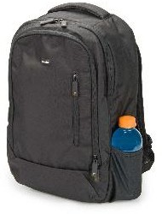
UrbanPro Laptop Backpack
Features | The UrbanPro Backpack includes a padded laptop compartment, water bottle holders, USB charging port, multiple zip pockets, and an anti-theft hidden  pocket.
Functions | It carries and protects your laptop, books, gadgets, and personal items. The USB port lets you charge your  phone while walking. The hidden pocket keeps valuables safe.
Benefits | It keeps everything organized and safe while you're on campus or commuting. It reduces shoulder strain  and makes it easier to carry study materials all day.
Materials | Made from water-resistant polyester fabric with padded foam inside and strong zippers for long-  lasting use.
Size and dimensions | It measures 45 cm (H) x 30 cm (W) x 15 cm (D) and  weighs about 0.9 kg. It fits laptops up to 15.6 inches.
Color, shape, design | Available in black, navy blue, and grey. The backpack has a slim, rectangular shape with a modern and  minimalist design.
Price and value | It costs $49. For the features it offers, it gives great  value for students on a budget.
Target audience | Perfect for university students, college learners, and young professionals who need a reliable and stylish  everyday backpack.

UNIT 6

Recent Development in Information Technology


Learning Outcomes:
By the end of the lesson, the students are expected to be able to use appropriate English to:
  - identify, describe and explain the recent developments on video games.
  - identify, describe and explain other recent developments on IT.
  - make predictions using future tense.
  - identify and explain procedures of making a summary.
  - identify and explain anatomy of making a summary.
  - make a summary of an article of an IT journal.

Video Games

Exercise 1: Work in pairs. Discuss these questions:
  - Do you play video games? What kind of game is it?
  - How and where do you play it? How long do you play it a day?
  - What are your favorite video games? Make a list. Why do you like them?

Exercise 2: Label the pictures (A-F) with the types of the game.

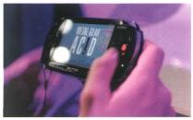

    - PC games
    - console games
    - arcade games
1 2 D. handheld games
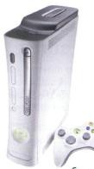

- mobile phone games
- massively multiplayer online games
4
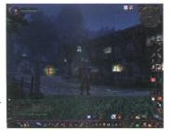

3
5 6

Exercise 3: Video games are played on a variety of electronic devices, or platforms. Complete these sentences with game platforms from the box and types of games from exercise 2.
personal computer video game consoles portable gaming devices 3G mobile phones

- are played on , such as the Sony PS3 or Microsoft Xbox 360. In the past thee electronic devices were just connected to a standard TV or video monitor; now they can also be connected to the Net, via cables or wirelessly.
- are played on , such as the Sony PSP and the Nintendo DS. You can also play games on some graphing calculators and watches.
- Don’t worry if you don’t have a game console. You can still play on a . The graphics are even more impressive if you have a high-resolution monitor. You can buy games on CDs and DVDs, or download them from the internet.
- allow you to play against other users in other parts of the world using the internet - something unique to electronic gaming. Players connect to a game server hosted by an ISP, a game company, or an individual enthusiast.
- Some are programmed to run natively on the chip of
. For instance, Snake is installed on many Nokia phones. Many Java-based games are also available via download.
- are played on coin-operated machines, typically installed in restaurants, bars, and amusement arcades. For example, you can play an aircraft or a spaceship using a joystick

Exercise 4: How many different game genres can you think of? In pairs, make a list and then read the text to see how many genres from your list are mentioned.
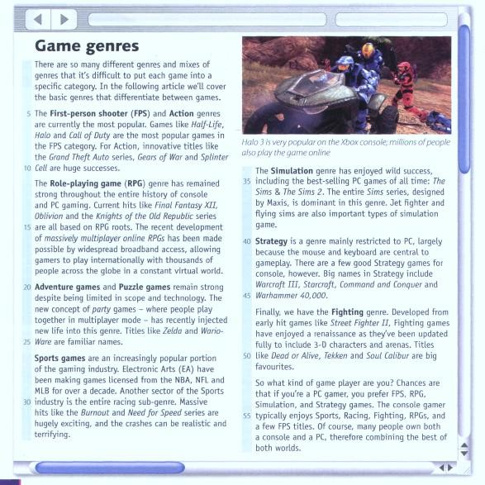

Exercise 5: These statements about gaming are all false. Read the text again and correct them.
- Role-playing games are currently the most popular.
- Massively multiplayer online RPGs have been made possible by widespread internet access.
- Oblivion is an Action game.
- The Sims series is the least popular in the Simulation category.
- Strategy games are mainly restricted to game consoles.
- Warcraft belongs to the Fighting genre.
- Console gamers typically prefer Simulation and Strategy games.

Exercise 6: Find words or phrases in the text with the following meanings.
- now; at this time or period (lines 5-10)
- existing or happening in many places and/or among many people (lines 15-20)

- in spite of; notwithstanding (lines 20-25)
- more and more (lines 25-30)
- a smaller category within a particular genre (lines 30-35)
- big successes (lines 30-35)
- sold in very large number (lines 35-40)
- modernized (lines 45-40)

Exercise 7: Listen to an interview with Matt Robinson, the administrator of the TPS Report gaming blog. How many game platforms does he mention?

Exercise 8: These statements below are false. Listen to the interview again, and correct them.
- Video games are popular because they are fun and addictive.
- Well-known Hollywood actors appear in video games.
- The Nintendo Wii is aimed at hardcore gamers.
- It’s free to play World of Warcrafts.
- Holography is an advanced form of photography that uses lasers to produce two-dimensional images.

- In the future, gesture recognition systems will produce photo-realistic images.

Exercise 9: In pairs, look at the statements about gaming and say if you agree or disagree with them. Give reasons for your answer.
- TV and video games are amusing and can be educational. But too much of this kind of entertainment can be addictive and make children accustomed to violence.
- Massively multiplayer online games are interactive and fun.
- Video games have negative effects on children and distract them from school and homework.
- Modern games and simulations offer a great deal of adventure and challenge. In addition, they can teach skills such as strategic thinking, interpretative analysis, and problem solving.

Exercise 10: Write an essay explaining your opinions about the topic on Exercise 9. Use these procedures and the expressions below to guide you.

Procedures:
- Paragraph 1: Opening
Present the topic in one or two sentences.
- Paragraph 2 and 3: Body
Give pros (arguments in favor) and cons (arguments against) with facts and examples.
- Paragraph 4: Closing
Summarize your main ideas and give your opinions.

Useful expressions:

- To add arguments: In addition, …….. Furthermore, …. Moreover, …….. | - To express opinions:  In my opinion, …  It seems to me that … I believe that …  It’s clear that ….
- To introduce opposing ideas:  On the one hand, …. Some people say …. On the other hand, Others say, …  However, …. | - To conclude: In conclusion, To sum up, … In short, ….

Other Current Developments in IT

Exercise 11: In pairs, discuss these questions.
  - What do you think a trend is?
  - What current developments in IT do you know? What is it? Mention some. How does it affect your life?

Exercise 12: Read the text and answer the questions.

Recent Developments in Information Technology

Information Technology (IT) is changing very quickly. New inventions are helping people to work faster, communicate more easily, and live more comfortably. One of the most important developments in IT today is the use of artificial intelligence (AI). AI is used in many places, such as smartphones, websites, and even cars. For example, voice assistants like Siri and Alexa use AI to understand and answer questions. AI is also used in businesses to check data and find useful patterns.
Another big change in IT is cloud computing. In the past, people saved files on their computers. Now, many people use the cloud to store their documents, photos, and videos online. This makes it easier to access information from any device. Companies also use cloud computing to run their websites and store large amounts of data.
Cybersecurity is becoming more important, too. As more people go online, hackers are trying to steal personal information. Because of this, IT companies are working hard to make systems safer. They use tools like two-factor authentication and encryption to protect user data.
In recent years, there has also been a rise in remote work. Thanks to video conferencing tools like Zoom and Microsoft Teams, many people can now work from home. This was especially useful during the COVID-19 pandemic. Some companies have continued remote work even after the pandemic.
Finally, 5G technology is changing how we use the internet. It is much faster than 4G and helps devices connect quickly. This is useful for streaming videos, playing games online, and using smart home devices. Experts believe that 5G will also help self-driving cars and other new technologies in the future.
In conclusion, information technology continues to grow and improve. These new tools are making life easier, but they also bring new challenges. People need to understand and adapt to these changes.

Choose the best answer.
- What is one example of artificial intelligence (AI)?
  - Cloud storage

  - Siri
  - Zoom
  - Microsoft Word
- What is a benefit of cloud computing?
  - It replaces smartphones.
  - It works without the internet.
  - It lets you access files from any device.
  - It protects against viruses.
- Why is cybersecurity important?
  - To help AI learn faster
  - To store photos online
  - To protect personal information
  - To increase download speed
- What tool is used for remote work?
  - Alexa
  - Siri
  - 5G
  - Zoom
- What technology helps self-driving cars?
  - 5G
  - Cloud storage
  - Zoom
  - Siri
- What do companies use AI for?
  - writing emails
  - finding data patterns
  - printing documents
  - saving power
- What happened during the COVID-19 pandemic in IT?
  - People stopped using the internet.
  - AI was banned.

  - More people worked remotely.
  - Computers stopped working.
- What is used to protect online accounts?
  - Voice assistants
  - Encryption and two-factor authentication
  - Cloud storage
  - Smart home devices
- What is a smart home device likely to use?
  - 3G
  - 4G
  - 5G
  - USB
- What is the main idea of the text?
  - Technology is dangerous
  - IT is no longer useful
  - IT is changing and affecting daily life
  - People don’t need computers

Exercise 13: Listen to Sarah Wood, an ICT teacher, giving a class about RFID tags. Choose which definition best describes RFID?
- A smart technology worn on the user’s body so that they can email and access the Web.
- A technology that uses radio waves and chip-equipped tags to automatically identify people or things.
- A technology that uses microchips and bar codes to track people or things at the distance.

Exercise 14: Listen Sarah’s talk again and choose the correct answer.
  - RFID stands for
    - Radio Frequency Identification
    - Radio Frequency Identification Download
  - Radio tags
    - can only be attached to or embedded into products
    - can be attached to or embedded into products, animals and human

  - Active RFID tags
    - have a communication range of several hundred meters.
    - have a communication range of five meters
  - RFID chips
    - Will help us track ordinary objects when they are lost or stolen.
    - Won’t be able to track ordinary objects when they are lost or stolen.
  - Radio tags can be implanted under the skin
    - To confirm a patient’s identity and cure illness
    - To give the doctor instant access to the patient’s history.
  - According to Consumers Association, RFID tags
    - could be used to track consumers or to steal a person's identity
    - are secure and private. There is no need for concern.

Grammatical Functions: Simple Future Tense

Exercise 15: Read the following explanation about the expression used for making predictions. After you understand it, make predictions about the given things using the expression you have learned.
Making Predictions
Study these expressions used to make predictions
Many more people will use the Internet.
Doctors will experiment with new procedures on simulated patients. Micro-machines are going to be used for drug delivery.

We can use will and is/are going to make predictions about things we are confident will happen.

- the number of PCs in use.
- the power of computer.
- the capacity of storage device.
- the size of computer.
- robots and housework
- computers and cars
- the price of computers
- the use of smart card

Writing a Summary of an IT Related Article

Reading a journal article is necessary to get ideas for your final project or thesis report. Therefore, you need to know the theory and procedures of summarizing it.

Definition:
A summary is a short version of a longer text. It gives the main ideas without all the details. When you summarize, you use your own words to explain what the article is about. A good summary is short, clear, and easy to understand.

Principles:

Read to Understand, Not to Copy:
The goal is to understand the article, not just repeat it. Focus on the main points and important ideas.

Use Your Own Words:
A summary should not be copied. Try to explain the article like you’re telling a friend who doesn’t know much about IT.

Keep It Simple:
Use simple language. Do not include complex examples or technical details unless they are very important.

Be Objective:
A summary does not include your opinion. Just write what the article says.

Procedures:

Step 1: Read the Article Carefully
  - Read the whole article once to understand the topic.
  - Look at the title, headings, and first sentence of each paragraph. These usually show the main ideas.

Step 2: Highlight the Key Information
  - Highlight or underline:

    - Main topic
    - Supporting points
    - Any important findings or results
  - Ignore examples, long explanations, and technical words you don’t need.

Step 3: Write Notes in Your Own Words
  - Write short notes using simple English.
  - Do not copy long sentences from the article.

Step 4: Organize the Summary
  - Start with one sentence that gives the main idea of the article.
  - Then, write 3–5 more sentences that explain the important points.
  - Keep the summary short—about one paragraph (5–7 sentences).

Step 5: Check Your Work
  - Make sure you:
    - Used your own words
    - Included only the important ideas
    - Did not give your opinion
    - Used simple and correct grammar

Example Summary Sentence Starters:
  - “This article talks about…”
  - “The main idea is that…”
  - “One key point is…”
  - “The article explains how…”
  - “In conclusion, the article shows…”

Anatomy of an Article:
An article, especially from an academic or IT journal, usually follows a standard structure. This structure helps readers understand the purpose, content, and results of the article easily.
Here are the main parts (or "anatomy") of a typical article and what each part does:

Title
  - What it is: The name of the article.
  - Purpose: To show what the article is about in a few words.
  - Tip: The title helps you understand the main topic quickly.
Example: “The Impact of Artificial Intelligence on Cybersecurity”

Abstract
  - What it is: A summary of the whole article (usually 150–250 words).
  - Purpose: To tell you the main idea, methods, and results of the article in a quick read.
  - Tip: Read the abstract first to decide if the article is useful to you.

Introduction
  - What it is: The beginning of the article.
  - Purpose:
    - Introduces the topic
    - Explains the background
    - States the purpose or research question
  - Tip: Look for the main idea or goal of the article here.

Methodology (or Methods)
  - What it is: A section that explains how the research or study was done.
  - Purpose: To describe the tools, steps, and process used to collect data.
  - Tip: In IT articles, this may include software, experiments, or algorithms.

Results (or Findings)
  - What it is: A section that shows the outcomes of the research.
  - Purpose: To present what was discovered through charts, graphs, or descriptions.
  - Tip: Focus on the main results, not every detail.

Discussion (or Analysis)
  - What it is: A part where the writer explains what the results mean.
  - Purpose: To interpret the data and connect it to the bigger topic.

  - Tip: This section may compare the results to past studies.

Conclusion
  - What it is: The final part of the article.
  - Purpose: To summarize the key findings and suggest future research or actions.
  - Tip: Often repeats the main message in a short, clear way.

References
  - What it is: A list of books, articles, or websites the author used.
  - Purpose: To show where the information came from and give credit.
  - Tip: You can use these sources for further reading or research.

Exercise 16: In pairs, find an article in an IT journal. Then, identify the anatomy of the article. Make a summary based on the example above, and present it to the class.

REFERENCES

Esteras, Santiago Remacha. (2010). Infotech English for Computer Users Workbook.
Cambridge: Cambridge University Press.
Esteras, Santiago Remacha. (2011). Infotech English for Computer Users Student’s Book.
Cambridge: Cambridge University Press.
Glendinning, Eric H and McEwan, John. (2012). Basic English for Computing Revised and Updated. Oxford: Oxford University Press.
Hill, David. (2012). English for Information Technology Vocational English Course Book 2.
Essex: Pearson Education Limited.
Fabre, Elena Marco, dan Esteras, Santiago Remacha. (2007). Professional English in Use: ICT. Cambridge: Cambridge University Press.
Olejniczak, Maja. (2011). English for Information Technology 1 Vocational English Course Book. Essex: Pearson Education Limited.

